**SUMMER PRACTICE REPORT ON THE R/C STRUCTURE DESIGN OF THE** [**FOUR-STOREY BUILDING**](http://tureng.com/tr/turkce-ingilizce/5-storey%20building)

**The Course Code:**CE400

**Name:**

**Surname:**

**Student No:**

**Date of Completion of Report:** September, 2016

**Dates of Summer Practice:**  July 25, 2016- August 27, 2016

**TABLE OF CONTENTS**

**Introduction………………………………………………………………………………………………...3**

**Preface………………………………………………………………………………………………………6**

**Main text…………………………………………………………………………………………………....8**

**Interview with the supervisor……………………………………………………………………………34**

**Conclusions……………………………………………………………………………………………..…35**

**Appendices………………………………………………………………………………………………...36**

**Notation……………………………………………………………………………………………………37**

**References…………………………………………………………………………………………………38**

**INTRODUCTION**

As an undergraduate student, studying under the faculty of Civil Engineering, I am required to participate in a summer practice to enlarge my skills in engineering in the extent of both experience and knowledge. According to the principles of my faculty, there are two of these summer practice that every student has to fulfil in order to have a complete graduate standing as a Civil Engineer.

According to my subjective evaluation of the structure of education in the engineering faculty, there are two main components included. One of those two bases is the theoretical education that is completely based on technical information and scientific examination of the specific field of engineering, such as electrical and electronics engineering. The remaining main base of the education is the laboratory experimentations. Throughout the four semesters, second and third years of education, we are introduced by many theoretical knowledge on the materials and strength. However, this excessive loading of information is strengthened and balanced by laboratory experimentations that allow the student literally observe the knowledge that has already been gathered.

In the summer of 2015-2016 education periods, I attended my second summer training course, coded as CE400 by the Middle East Technical University- Faculty of Engineering, in a company named PROMER Consultancy Engineering Inc. that is specialized on design. This report is an informative commentary on the operational structure of PROMER and most importantly an investigation on my personal development throughout the summer practice, in the means of both specific academic knowledge on Civil Engineering and experience about the professional work life.

At the end of summer practice I have learned many things about civil engineering and its place in daily life. We see what civil engineers design and how they do this job.

The project that I was engaged in during my summer practice is theR/C structure design of the [four-storey building](http://tureng.com/tr/turkce-ingilizce/5-storey%20building).There is continuous footing at foundation and there are 1 block and 4 floors.The housing space is 854.4 m², closed space is 768 m² and land area is 221 m². At the building, there are 4 single rooms and 2 balconies for each floor. Totally, there are 16 rooms and 6 balconies. The living space of floors are: Ground floor 192 m², 1. Floor 206.4 m², 2. Floor 206.4 m², 3. Floor 206.4 m², 4. Floor 206.4 m². (Figure.1) The elevation of floors are: Ground floor +0.00 m, 1. Floor +3.00 m, 2. Floor +6.00 m, 3. Floor +9.00 m, 4.Floor +12.00 m.

The [three dimensional modelling](http://tureng.com/tr/turkce-ingilizce/three%20dimensional%20modelling) study that I was engaged in during my summer practice is below:

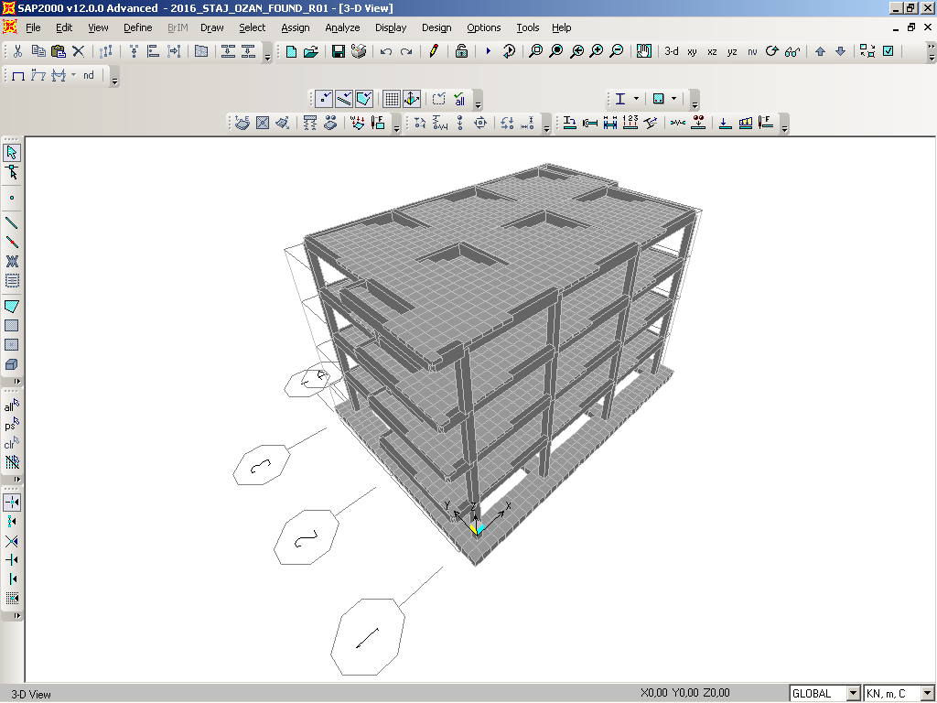

**Figure 1.** The sketch of [four-storey building](http://tureng.com/tr/turkce-ingilizce/5-storey%20building)

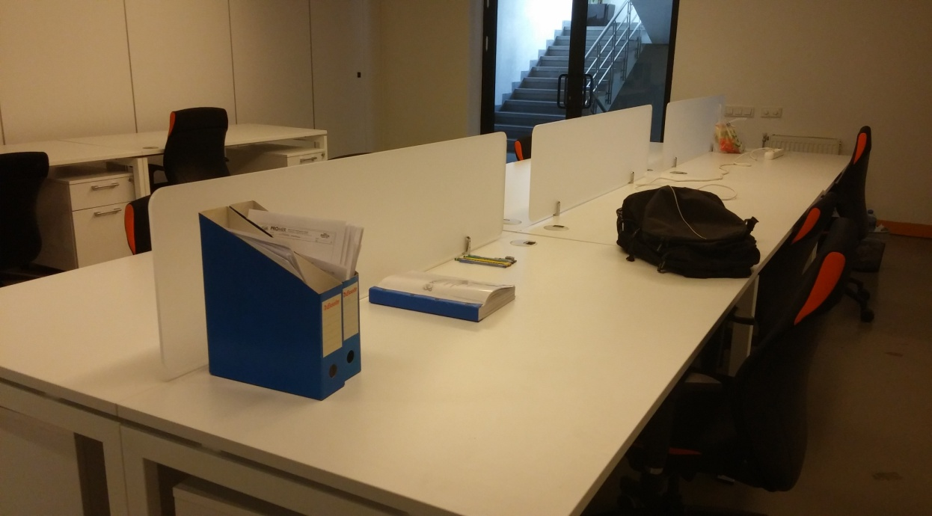

**Photograph 1.** A view of my first working area

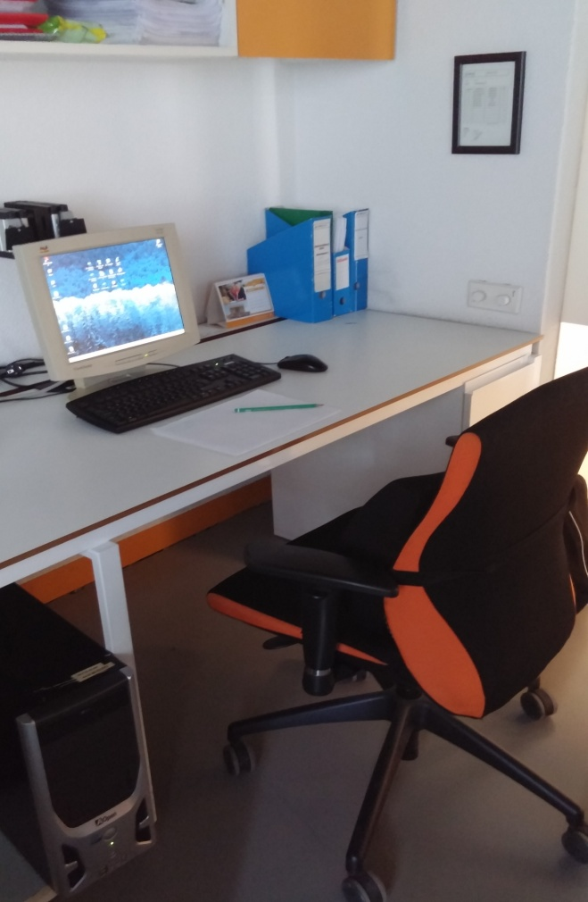

**Photograph 2.** A view of my second working area

**PREFACE**

The name of company that I did summer practice is PROMER Consultancy Engineering Inc. The location of the center office is Mutlukent Neighborhood, 5th Street, Street 1967 (Old Street 95), Number 14, Postcode 06800 Ümitköy/ ANKARA. The location of the İstanbul office is Küçükbakkalköy Neighborhood, Kayışdağı Street, Street Ayşe Hatun Çeşme, Number 2, Kestel Plaza 5th Floor, Postcode 34750 Ataşehir/ İSTANBUL.

PROMER Consultancy Engineering is a firm that is giving engineering service to its national and international customers from Mexico to China.

PROMER has the ability to utilize the last versions of the technological design and detaling instruments; and has the capability to take the advantage of the national and international building codes (TS, EuroCode, DIN, BS, UBC, SNIP, AISC) . PROMER is aware of the fact that the customer satisfaction provided by the most economical and the most applicable detail is the crucial point in our job.  
Power Plants, Mining Plants (gold, bor...), Chemical Industry, Petro-Cemistry Industry, Cement Plants, Flue Gas Dedusting Systems are the expertness fields of PROMER Cousultancy Engineering. The fundamental services offered by the firm are:

* Architectural Designs
* Industrial Buildings Engineering Services
* Electrical, Mechanical and Installation Design Services
* Infrastructure Designs
* Treatment Plant Designs
* Feasibility Studies
* Consultancy Services
* Site Supervisioning

PROMER Consultancy Engineering takes pride of completing his scope within the schedule and budged with management of his experts. The evidence of this pride is, PROMER Consultancy Engineering serving national and international companies who are leaders of their sectors for many years.

Some of the major projects completed by PROMER Inc. in Turkey include design of Emet Boric Acid Plant(Kütahya), MNG Jet Maintenance Hangars(Istanbul), Biga Autoproducer Power Plant(Çanakkale), Bigadiç 2nd Homogenization Unit(Balıkesir), Anagold Çöpler SART Plant(Erzincan), Yenipazar Polymetallic VMS(Yozgat), Kırka Pit Run Solubilizing Unit(Eskişehir), MNG Ayazaga Cargo Terminal(Istanbul), Kaymaz Gold Mine Plant(Eskişehir), Efemçukuru Gold Mine Plant(İzmir).

Some of the large-scale projects designed by PROMER Inc. include the; Lafarge Teresa Cement Plant (PHILIPPINES), Lafarge Norzagaray Cement Plant (Bulacan / PHILIPPINES), Aleppo Cement Plant(Aleppo / SYRIA), Yamama Cement Plant(Riyad / SAUDI ARABIA), Thai Nguyen Cement Plant(Thai Nguyen / VIETNAM), EMCC Cement Plant(Fujairah / UNITED ARAB),

Present structure and organizational scheme of design department is showed at below:

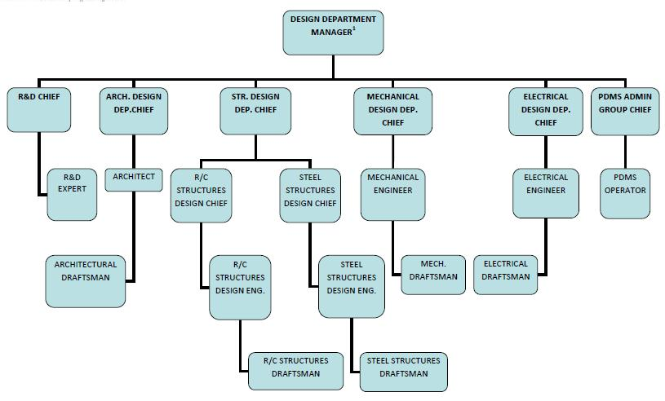

**Figure 2.** The organization scheme of design department

There are a lot of people from different engineering branchs in this company: 17 civil engineers, 8 mechanical engineers, 5 electrical engineers, 1 mining engineer and also 1 agricultural engineer:  
Yüksel Tonguç (Director), Hasan Başaran (Vice Director), Altuğ Bayram(Vice Director), Ahmet Cem Sayar(Business Development and Quotation Department Manager), Mehmet Selim Öztürk(R/C Structures Design Chief), Volkan Aydoğan(Steel Structures Design Chief), Yasemin Yurtseven- (H&R Manager -Agricultural Engineer), Arzu İşeri(Electrical Department Director), Ali Rıza Yücel(Civil Engineer), Arda Evcimen(Civil Engineer), Arzu Hepgüler(Mechanical Engineer), Bilge Demircan(Civil Engineer), Bülent Ogan Doğandündar(Mechanical Engineer), Cemal İlhan(Civil Engineer), Cemal İçel(Civil Engineer), Ceren Hoşgit(Mining Engineer), Emine Ceren Usalan(Civil Engineer), Engin Balıkçı(Electrical Engineer), Göksun Uçar( Mechanical Engineer), Hamza Ali Aygenç(Mechanical Engineer), Kıvanç Özkorucu(Mechanical Engineer), Korhan Çalın(Mechanical Engineer), Mesud Çalışkan(Civil Engineer), Mine Bayır(Mechanical Engineer), Mohammad Rahmani( Mechanical Engineer), Orhan Şenol Şahin(Electrical Engineer), Ozan Köse(Civil Engineer), Pınar Arıkoğlu(Civil Engineer), Samet Dönder( Electrical Engineer), Sinan Ahiska(Electrical Engineer), Tarık Özenç(Civil Engineer), Tuncay Taşçı- (Civil Engineer).

**MAIN TEXT**

**WEEK 1**

**DAY 1 - July 25, Monday- Paperworks & Program training**

In the first day of my internship, to get to work I delivered my school insurance certificate with other paperworks that company wants by hand to human resources department and registration procedures are done. The company always follow the logon/ rush hour and working hours of its employees with a program system called “AURO” which is integrated with fingerprints of them. After the registration process is finished, I registered my fingerprints and I took the information about AURO. I met with my supervisor Mr. Ozturk and he gave internship program activity report of the company for information purposes. Also, he submit the manual of the [“Standards](http://tureng.com/tr/turkce-ingilizce/standards) and auxiliary charts” that prepared by company for interns. And he requested to review manual from me.

**DAY 2 - July 26, Tuesday- Standard reading & Introduce to company**

First of all, I have showed around and was introduced to all staff by company secretary. Right after that I and my supervisor had a talk about how my review is going. I continued to review "TS500-Requirements for Design and Construction of Reinforced Concrete Structures" that I started yesterday.

**DAY 3 – July 27, Wednesday- Standard reading**

I started and finished to review the “Turkish Earthquake Code -2007”. I underlined that I think it is important. And also I wrote down formullas which I will possibly used.

**DAY 4 - July 28, Thursday- Standard reading**

Reviews of the “ TS498-Design Loads for Buildings” and “ TS648- Building Code for Steel Structures” are accomplished. In the afternoon, with my supervisor we talked what we will do next in the forthcoming days and agreed on starting the SAP2000 design.

**DAY 5 - July 29, Friday- MS Office program usage**

Today, the vice director Altuğ BAYRAM [called me away from my](http://tureng.com/tr/turkce-ingilizce/call%20someone%20away%20from%20something) working area and we met. He asked me how my internship is going and we talked about that. Also he asked me what we did for graphic design at lessons and how much I have a grasp of visual programming. Later on, a computer was assigned me and he made me do some works about visual design. He requested a presentation about departments and people who work on design of a petrochemical plant from me. He [told who work on the design of this type of structures and which ones(structural, architectural, mechanical, automation and control) are found at this company to me](http://tureng.com/tr/turkce-ingilizce/tell%20something%20to%20someone). I finished to prepare it after by writing parts in petrochemical plant and their details and name of design engineers and their duties. and their details and name of design engineers and their duties (Figure 3).

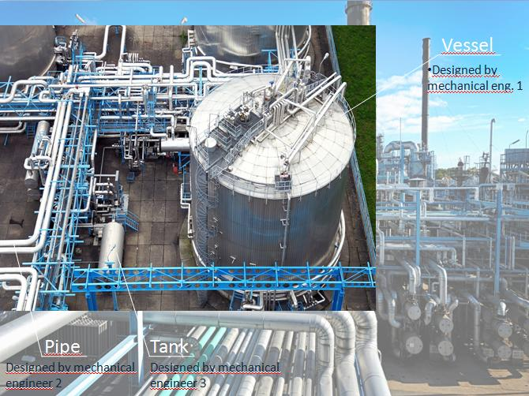 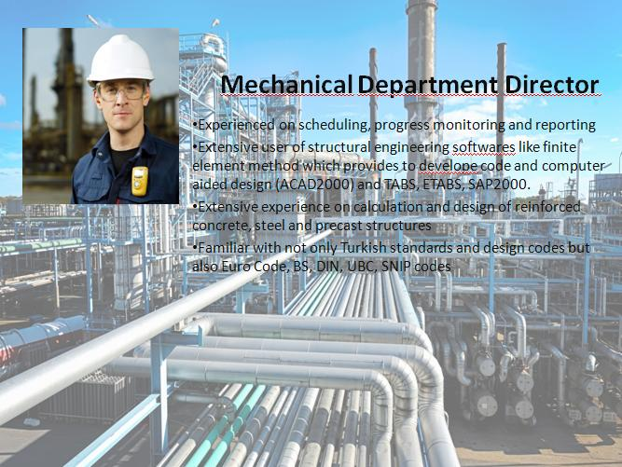

**Figure 3.** Several pages from powerpoint slide of thepetrochemical plant

**DAY 6 - July 30, Saturday- Starting the SAP2000 design**

I could start modelling that is my next task within the schedule, because I had finished to review standards. My supervisor created a template on paper and gave it to me with the necessary information about building. Additionally, he showed me show me how to use SAP2000 in [elemantarily](http://tureng.com/tr/turkce-ingilizce/elemantarily).

First of all, I got to work on modelling. A grid was created according to the properties of the building such as length, width, total height and number of floors. And later, I defined the properties of columns and beams and I drew beams which are 300x600 mm in size and columns which are 400x400 in size on this grid (Figure 4). A slab type named as “ d180” that compose of C25 concrete was defined for “ mesh area” and applied to all floors. Plus, I divided the slab to squares 0.5x0.5 m in size (Figure 4). The reason why we used it that is SAP2000 try to analyse the slab just for four points at corner in the first stage and this affect our design. However with the help of dividing the slab to pieces, the program analyse it for a lot of points and get better results. This is tousled the structure and extend the solving time of it. Lastly, all beams and columns were entitled starting from the ground floor sequentially to avoid probable confusions (Figure 5).

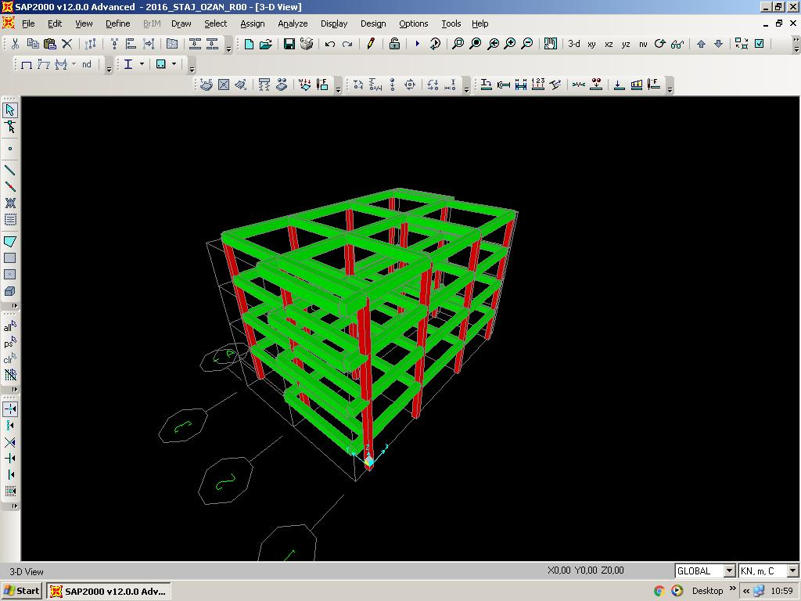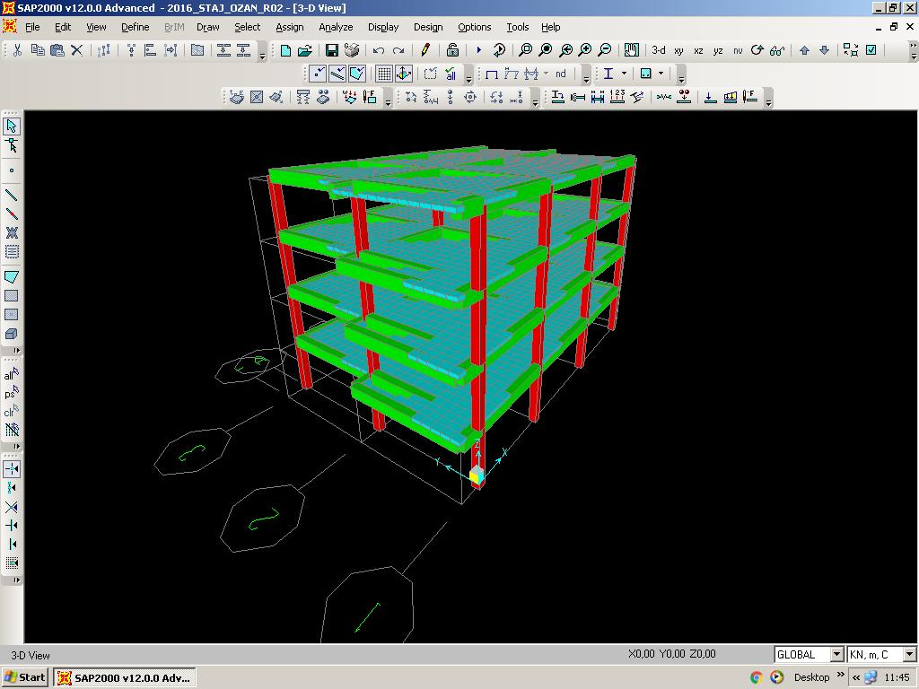

**Figure 4.** All columns and beams (left) and the slabs with mesh area (right)

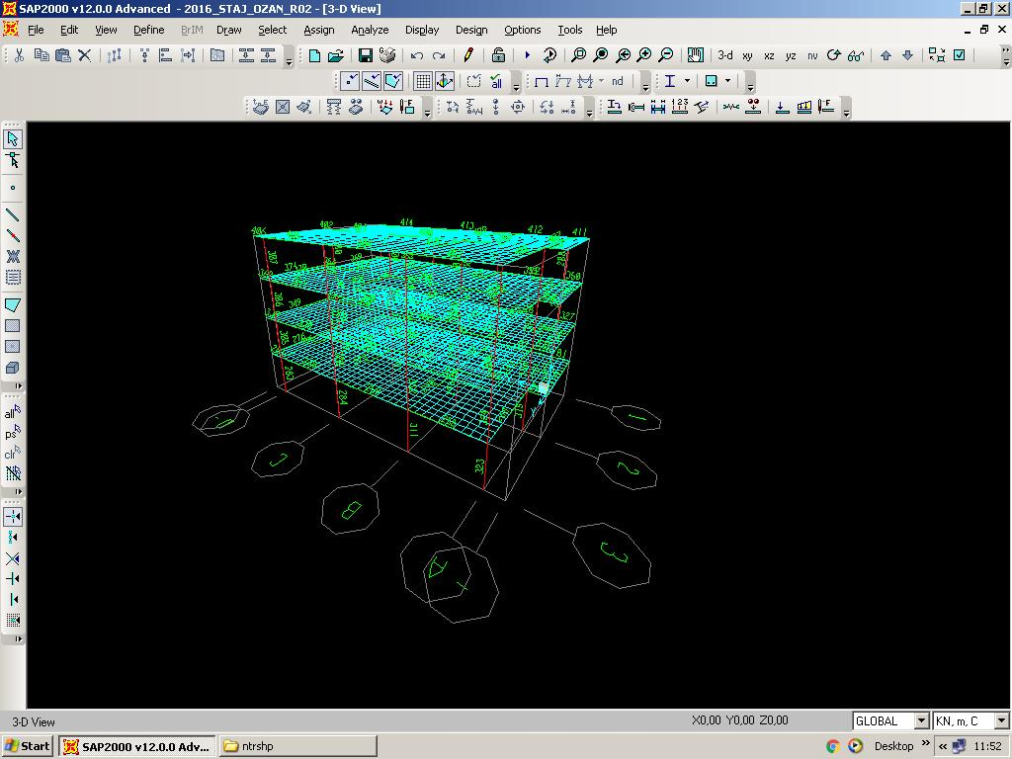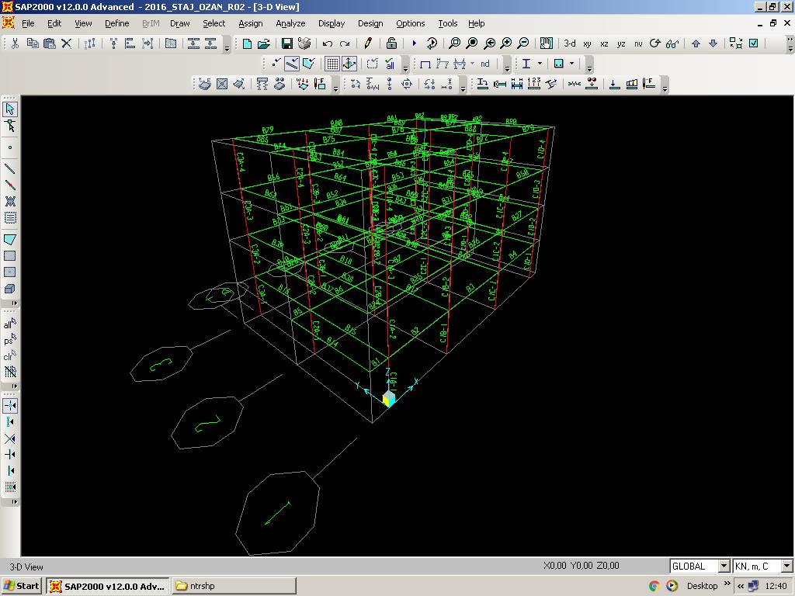

**Figure 5.** Entitling all columns and beams provide great convenience for later.

**DISCUSSION PART**

**WEEK 1**

The first week of my summer practice was tiresome for me. A couple of days, I tried to discover the company. I met all people who work at office. This was good for me because in remaining time of my summer practice I will communicate with these people. As far as I am concerned, the company attached importance to working hours of its employees. At design department, there are people master of their domain. When they carry out a work, they make tiny distinctions frequently. And seeing standards about designing was beneficial for me. Then I made out some knowledge learned in lessons and also I saw new things in standards. While I was preparing the presentation, taking directions from vice director made feel being engineering. In following days, I teached how all design loads for buildings- such as dead load, live load- calculated. At the last working day of week, I started the SAP2000 design. I used SAP2000 for the first time ever. SAP2000, is the one of the most used civil engineering programs, serves for modeling and analyzing any type of structure. Also any type of material and any type of section in the library of the program can be used. This provides an extensive usage area for the program. On the other hand, the most efficient works at this week are standard reading and starting the SAP2000 design. Thanks to learned these, I will study on many projects in my career.

**WEEK 2**

**DAY 7 – August 1, Monday- Defining load patterns, load cases and load combinations**

The next work on my modelling is that defining load patterns and combinations affect my building. I started to define the design loads for buildings like dead, live, earthquake and wind loads on SAP2000. My supervisor shared with me an old Excel file to be an example for load combinations that I calculated. I prepared appropriate combinations for the designed building after examining the standards are “ TS500- Requirements for Design and Construction of Reinforced Concrete Structures” and *“*2007 Turkish Earthquake Code” subsequently (Figure 6). Then together we checked and revamped them synchronously. Earthquake was accepted at two directions and they don’t affect at the same time according to Turkish Standard. Right after I added these combinations on SAP2000, he requested me to calculate design loads by benefiting from the standard “TS498-Design Loads for Buildings” . The load calculations that he asked for me are dead loads, live loads, wind loads and earthquake loads. Each one of them is calculated complying with regulations by taking unit weights into consideration.

**Table 1.**The table of load patterns

|  |  |  |
| --- | --- | --- |
| No: | Load Patterns | Description |
| 1 | DL0 | Own Weight of the structure |
| 2 | DL1 | Bucket elevator dead load at El.+0.00 |
| 3 | LL1 | Live Load included dust load |
| 4 | W+x | Wind Load for the RC structure in +x direction |
| 5 | W-x | Wind Load for the RC structure in -x direction |
| 6 | W+y | Wind Load for the RC structure in +y direction |
| 7 | W-y | Wind Load for the RC structure in -y direction |
| 8 | EQx | Earthquake Load for the Raw Mill Building RC structure in +x direction |
| 9 | EQy | Earthquake Load for the Filter Building RC structure in +y direction |
|  |  |  |

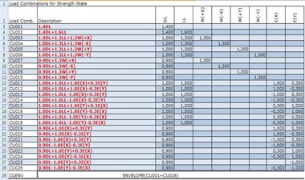

**Figure 5.** Load combinations for strength state, CU

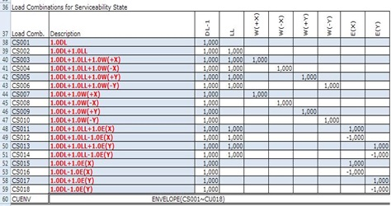

**Figure 6.** Load combinations for serviceability state, CS

**DAY 8 - August 2, Tuesday- Calculation of the dead and live loads**

We checked accuracy of the calculation of the design loads on documents that I have done previously. I [made correction](http://tureng.com/tr/turkce-ingilizce/make%20correction)s on calculations and values that is based on compution by following the instruction of my supervisor. [In the first step](http://tureng.com/tr/turkce-ingilizce/in%20the%20first%20step), I made these arrangements for dead and live loads. Also, my supervisor Mr. Öztürk suggested to use Excel with necessary figures for doing it easily [as well as](http://tureng.com/tr/turkce-ingilizce/as%20well%20as) using it for my summer internship report. In the next step, we controlled this last calculations and reviewed calculation of wind load. And all of these were viewed with calculations and visuals on Excel. I [grouped this editing on Excel under the two title](http://tureng.com/tr/turkce-ingilizce/collect%20under%20the%20same%20title) is named as [typical floor](http://tureng.com/tr/turkce-ingilizce/typical%20floor) and roof.

**DAY 9 - August 3, Wednesday- Calculation of the wind load**

I calculated the wind load that is last remaining from the calculations of the design loads I have done. [In the first instance](http://tureng.com/tr/turkce-ingilizce/in%20the%20first%20instance), I studied on related standard called as“ TS498-Design Loads for Buildings”. I skimmed through the calculation of wind load for enclosed building. I [took notes about formulas are required for this type of structures.](http://tureng.com/tr/turkce-ingilizce/take%20note%20of) These formulas are [collected under the two title](http://tureng.com/tr/turkce-ingilizce/collect%20under%20the%20same%20title): wind pressure and suction. I calculated these for related columns, beams and roof for four different directions separately (W+x, W-x, W+y,W-y directions). In the end, I showed all obtained values as a table on Excel (Table 2)

**Table 2.**The table of load calculations

**DAY 10 - August 4, Thursday- Defining member & Standard reviewing**

Mr. İçel, who is the another civil enginering at design department, requested me to carry out a duty for an actual work [in line with vice director's demand](http://tureng.com/tr/turkce-ingilizce/in%20line%20with%20someone's%20demand). This duty was that defining steel sections (C, H, L, I sections) that the owner wanted to use during the design phase on SAP2000 one by one. ( Command order on SAP2000: Define> Section Properties> FrameSections> Frame Properties) For this, I entered data that belongs to cross-section measurements. I cited geometrical moment of inertias, Ix and Iy from here and I entered these on Excel file [synchronously](http://tureng.com/tr/turkce-ingilizce/synchronously). And I compared between geometrical moment of inertias on Japanese Industrial Standards and on SAP2000. After by calculating a ratio between these values, together I and he evaluated whether sections are suitable for design and I delivered both files( Excel and SAP2000 files) to him. Also during these comparisons I distinguished that there is wrong geometrical moment of inertia for one section ( 175x 175x 11x 7.5) and corrected it. Three L sections that found in the material list send by owner were not written on Japanese Standards. Mr. İçel told that he will [make an explanation](http://tureng.com/tr/turkce-ingilizce/make%20an%20explanation) about that to owner. [Additionally](http://tureng.com/tr/turkce-ingilizce/additionally), I distinguished that the cross-section measurements of four H sections differed from their names when I worked on SAP2000 and made a calculation accordingly. (H500- 19, H500- 18, H600, H900)

**DAY 11 - August 5, Friday- Load transfer**

I added all calculated design loads to load cases at each related area, column and beam on SAP2000. Firstly I loaded live loads (LL) of the typical floor and the roof, I loaded dead loads (DL1) of them respectively. I loaded distributed loads such as parapet and wall loads that are handled by every beam on slab of the each necessary floor. In the meantime, direction, coordinate system, load pattern name and load were become more of an issue. At the latter end, I loaded wind load that is influenced on the columns from four different directions and on the roof by creating suction effect [individually](http://tureng.com/tr/turkce-ingilizce/individually). After all calculations were finished, I checked all of them [at the request of my](http://tureng.com/tr/turkce-ingilizce/at%20the%20request%20of%20someone) supervisor.

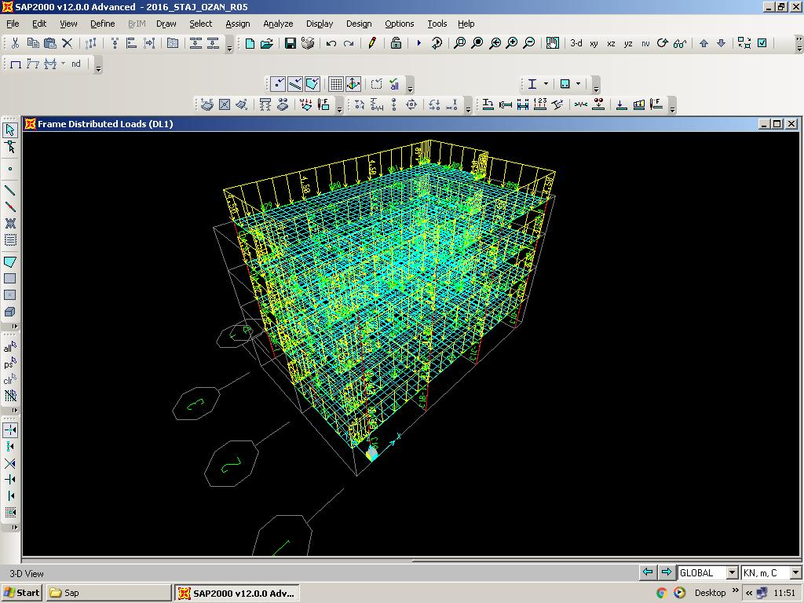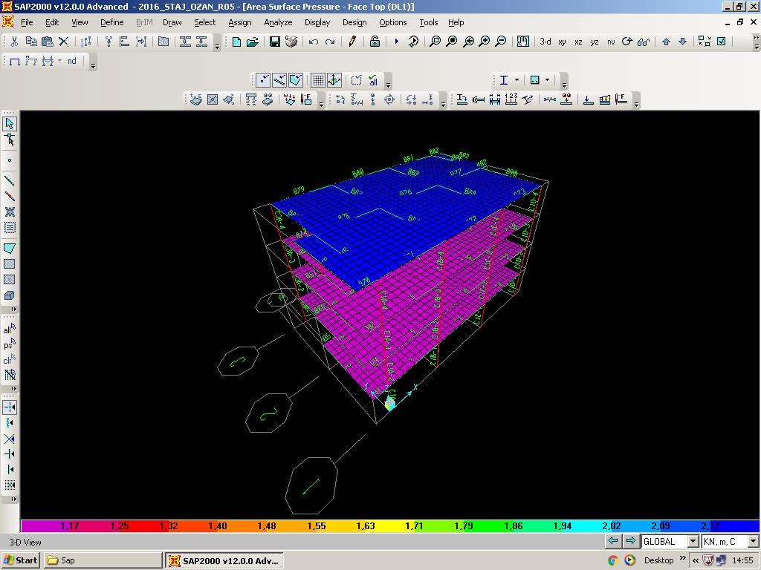

**Figure 7.** Frame distributed loads (left) and area surface pressure (right) of the dead load (DL1) are shown.

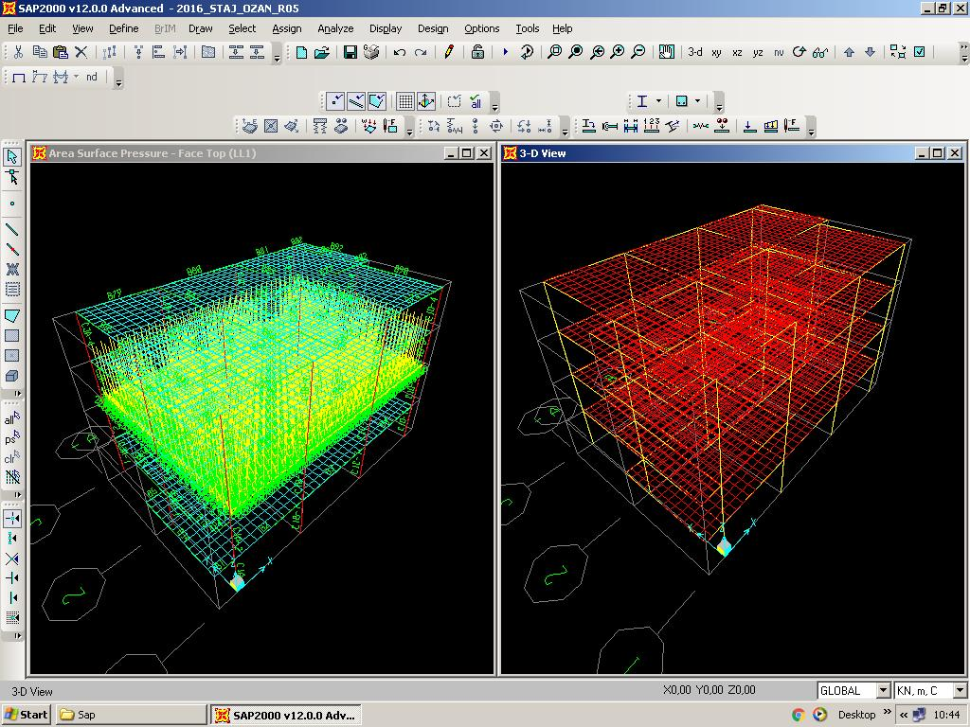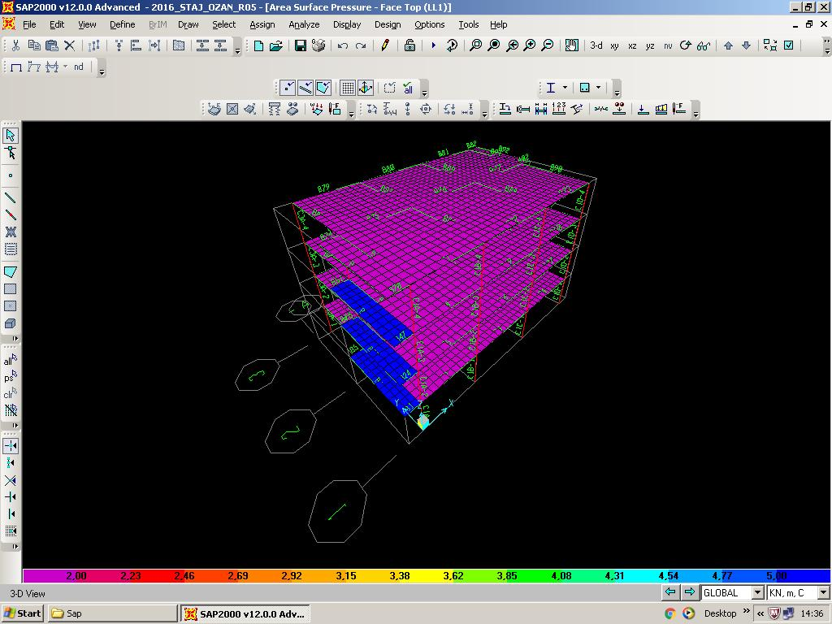

**Figure 8.** The area surface pressures of the live load (LL1) are shown.

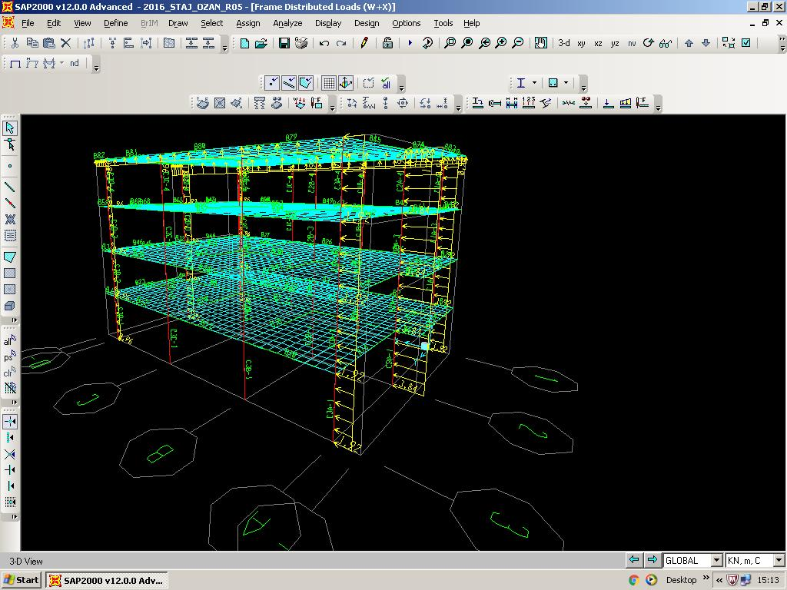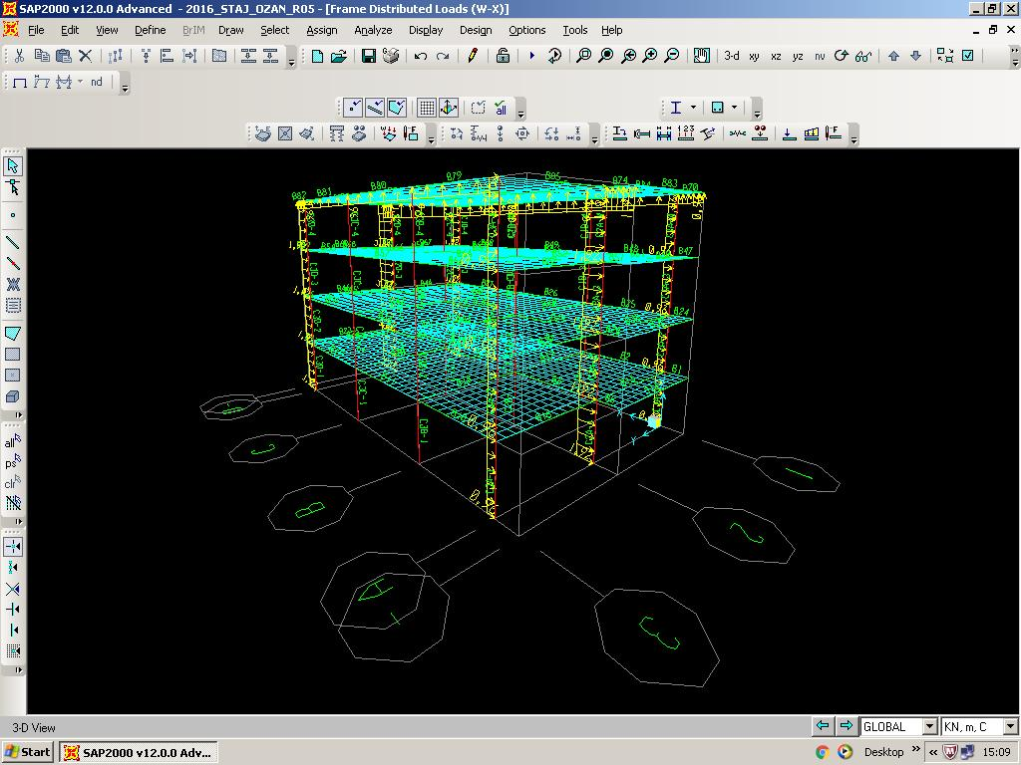

**Figure 9.** The wind loads, W+x (left) and W-x (right), are shown.

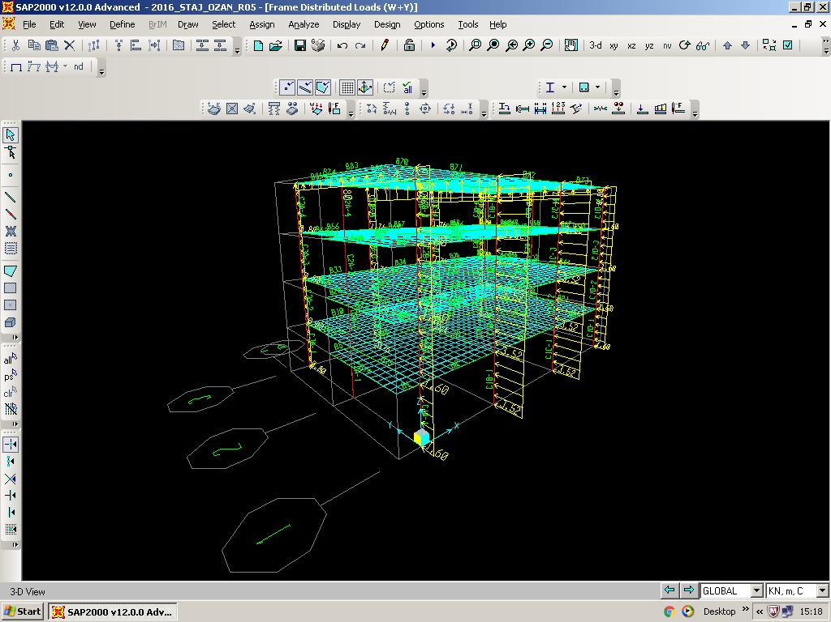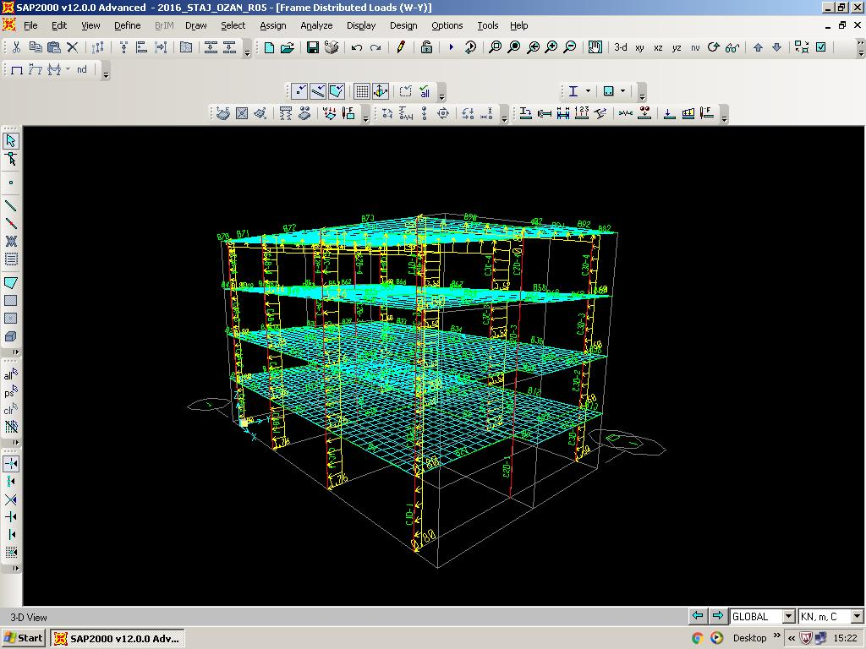

**Figure 10.** The wind loads, W+y (left) and W-y (right), are shown.

**DAY 12 - August 6, Saturday- Prota training**

And there was provided a training for Prota system that provide programs like Excel, Word, AutoCAD, SAP2000 for the use of company employees [within the body of](http://tureng.com/tr/turkce-ingilizce/within%20the%20body%20of) company interactively. The IT specialist [gave a briefing](http://tureng.com/tr/turkce-ingilizce/give%20briefing) us about usage of Prota. According to what he told, it lets through up to 10 people. After exceeding quota, it log out the exceeders automatically. Also, he asked for employees move fills of present works till end of today's working hour. The reason is that to increase the total capacity availability by deleting all earlier works. At the deadline, he actualised it.

**DISCUSSION PART**

**WEEK 2**

After the modeling part is done, the fundamental part of engineering starts. Loads are almost everything for calculations. The sizes of beams, columns and slab, the places of these members and, all are specified according to loads. So, Turkish Standards have different combinations for load cases. In SAP2000 we have to apply all cases to the model because for different situations any one of them could be the critical one. When the program is run, the results of the model can be seen and it has to be designed in accordance with the critical combination for safety. With loading the building and running the program either I will see the building is on the safe side and there is problem with the members or not.

In second week of my summer practice, I fronted calculations more as compared with first week. In the first working day of the week, I defining load patterns, load cases and load combinations. After taking some information about design loads for buildings, this was good experience for me. Now most of thing about it is more understandable. At second day, I started to calculate dead and live loads. The folowing day I passed on to calculation of the wind load. After you calculate these loads, your job doesn’t finish. You should load them to correct points on design. When you design, you should ensure that it is a long-lived building certainly.

Defining member is one step before starting the design and it is had great importance. I think that using double-checking reduces possibility of failure certainly.

Prota training may be [a very important improvement](http://tureng.com/tr/turkce-ingilizce/a%20very%20important%20improvement/development) for company in this week. Because all works are made on it from this day forward and making mistake at that may cause irremediable results. And engineers and draftsmans who work together will always take care about that.

**WEEK 3**

**DAY 13 - August 8, Monday- Calculation of the seismic load**

All calculations of load and load combinations had completed, I started calculation of the seismic weight on SAP2000. First of all, my supervisor wanted to skim through standard about ductility and columns of nominal ductility level. After doing this, in the light of acquired informations I made calculations. I obtained storey weights for per floor seperately and totally right after loading modelling on SAP2000. These values are arranged in Excel for further processes.

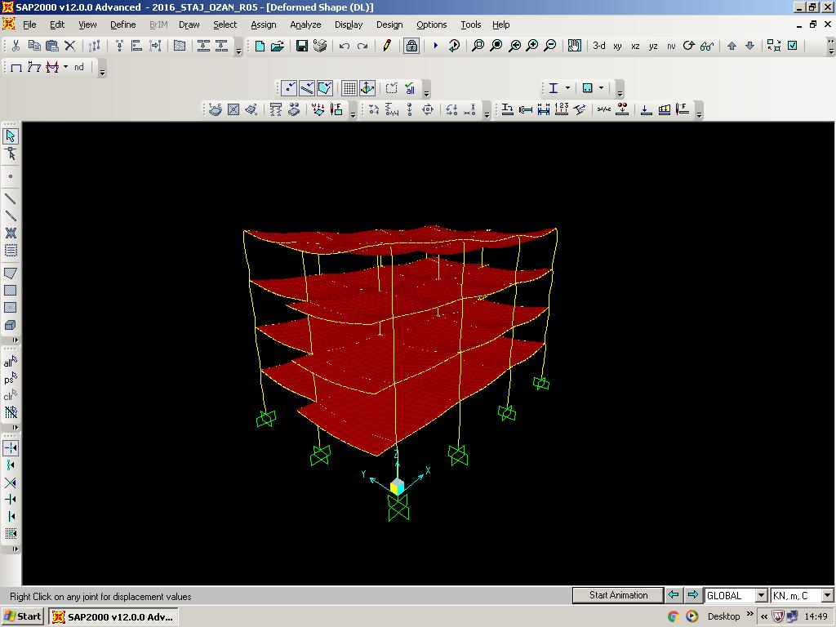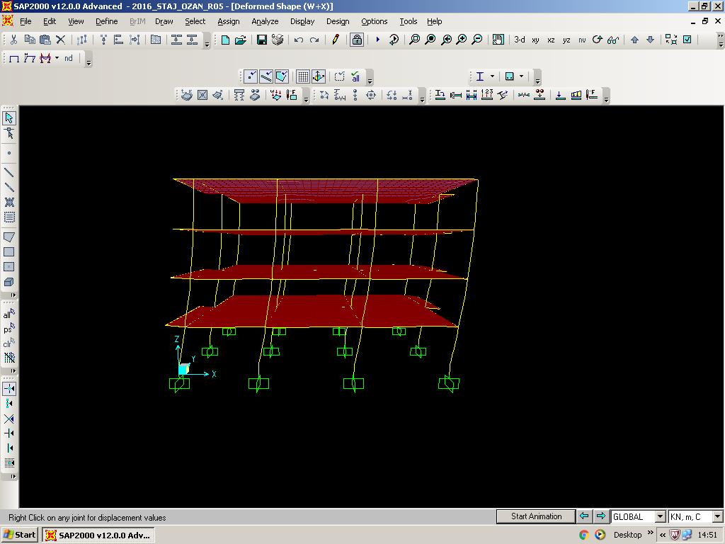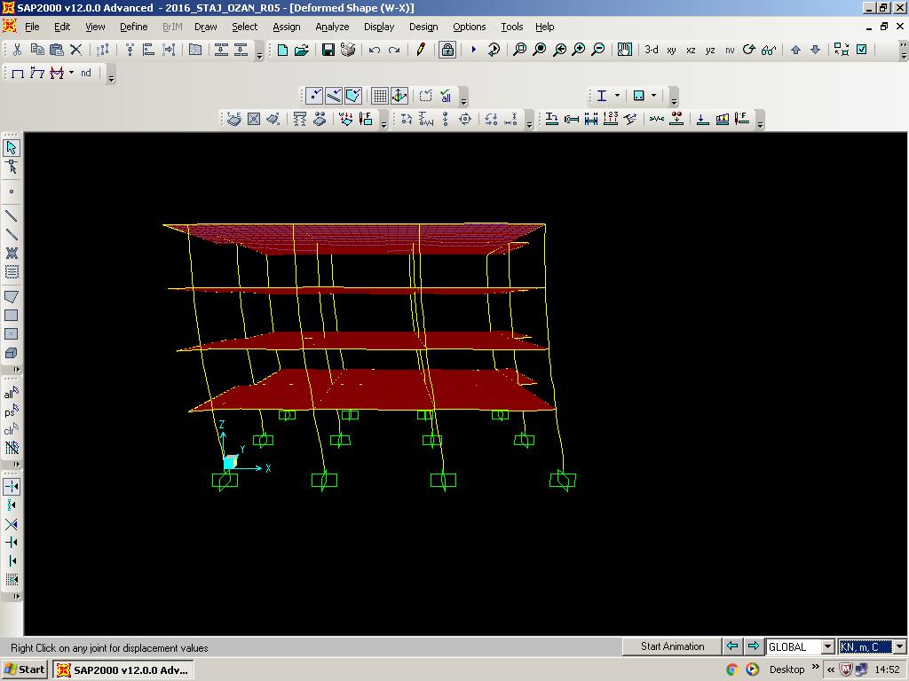

(b)

(c)

(a)

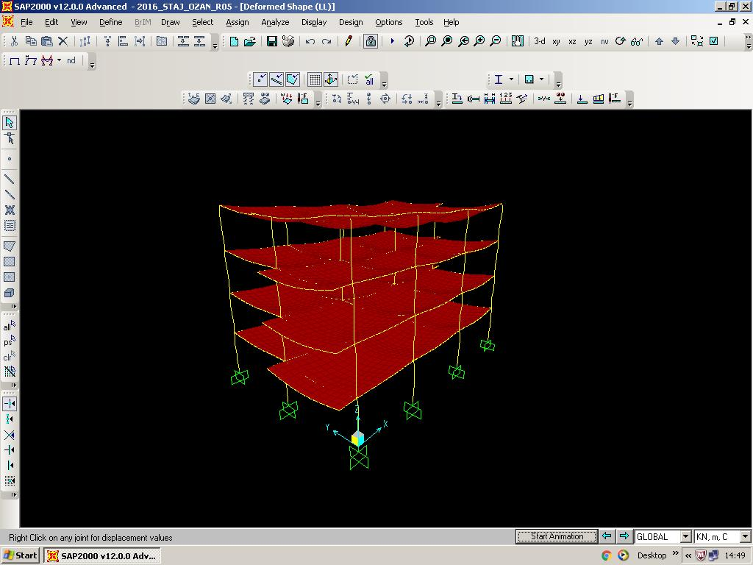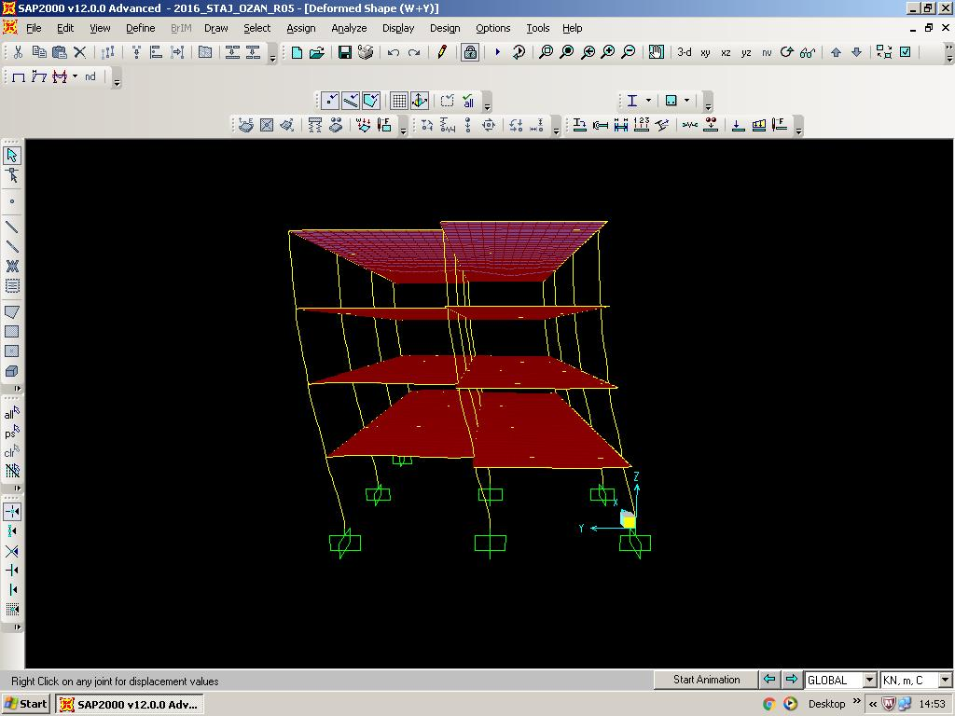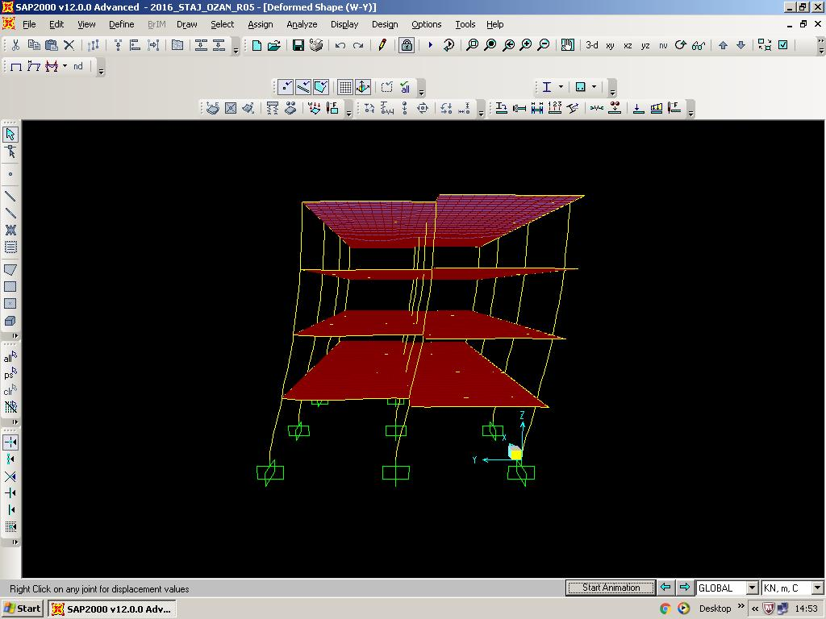

(d)

(f)

(e)

**Figure 11.** The deformed shape of building when loads are applied individually; DL(a), W+x (b), W-x (c), LL(d ), W+y (e), W-y (f).

**DAY 14 - August 9, Tuesday- Calculation of the seismic load**

According to storey weights calculated on Excel and Turkish Earthquake Code, design seismic loads acting at storey levels are determined. In the meantime, I proceeded step by step as indicated in standard. These finding values are loaded related beam-column joints in the modelling on SAP2000. And analysis/animation was followed in the light of these values.

**Table 2.** The table ofstorey weights and design seismic loads acting at storey levels.

|  |  |  |  |  |  |  |  |  |  |  |  |
| --- | --- | --- | --- | --- | --- | --- | --- | --- | --- | --- | --- |
| **LOADS AT STOREY** | | | | | | | | | | | |
|  | **Axis** | **A** | **B** | **C** | **D** | **W(kN)** | **Fi(kN)** | **EQ-A** | **EQ-B** | **EQ-C** | **EQ-D** |
| **Level 1** | 1 | 145,58 | 179,81 | 207,77 | 100,65 | 2624,33 | 86,14 | 4,8 | 5,9 | 6,8 | 3,3 |
| 2 | 263,17 | 383,13 | 422,94 | 287,47 | 8,6 | 12,6 | 13,9 | 9,4 |
| 3 | 88,59 | 187,89 | 201,18 | 156,15 | 2,9 | 6,2 | 6,6 | 5,1 |
| **Level 2** | 1 | 145,58 | 179,81 | 207,77 | 100,65 | 2624,33 | 172,27 | 9,6 | 11,8 | 13,6 | 6,6 |
| 2 | 263,17 | 383,13 | 422,94 | 287,47 | 17,3 | 25,2 | 27,8 | 18,9 |
| 3 | 88,59 | 187,89 | 201,18 | 156,15 | 5,8 | 12,3 | 13,2 | 10,3 |
| **Level 3** | 1 | 145,58 | 179,81 | 207,77 | 100,65 | 2624,33 | 258,41 | 14,3 | 17,7 | 20,5 | 9,9 |
| 2 | 263,17 | 383,13 | 422,94 | 287,47 | 25,9 | 37,7 | 41,6 | 28,3 |
| 3 | 88,59 | 187,89 | 201,18 | 156,15 | 8,7 | 18,5 | 19,8 | 15,4 |
| **Level 4** | 1 | 159,79 | 181,40 | 215,79 | 106,88 | 2709,17 | 382,66 | 22,6 | 25,6 | 30,5 | 15,1 |
| 2 | 279,72 | 376,77 | 419,72 | 305,25 | 39,5 | 53,2 | 59,3 | 43,1 |
| 3 | 93,59 | 194,25 | 205,20 | 170,82 | 13,2 | 27,4 | 29,0 | 24,1 |
|  |  |  |  |  | ΣW= | 10582,16 |  |  |  |  |  |

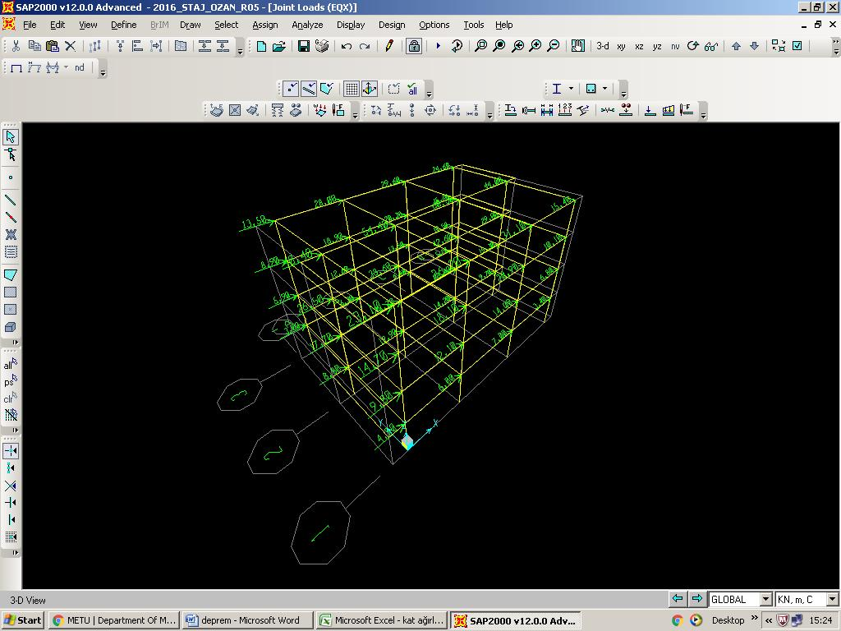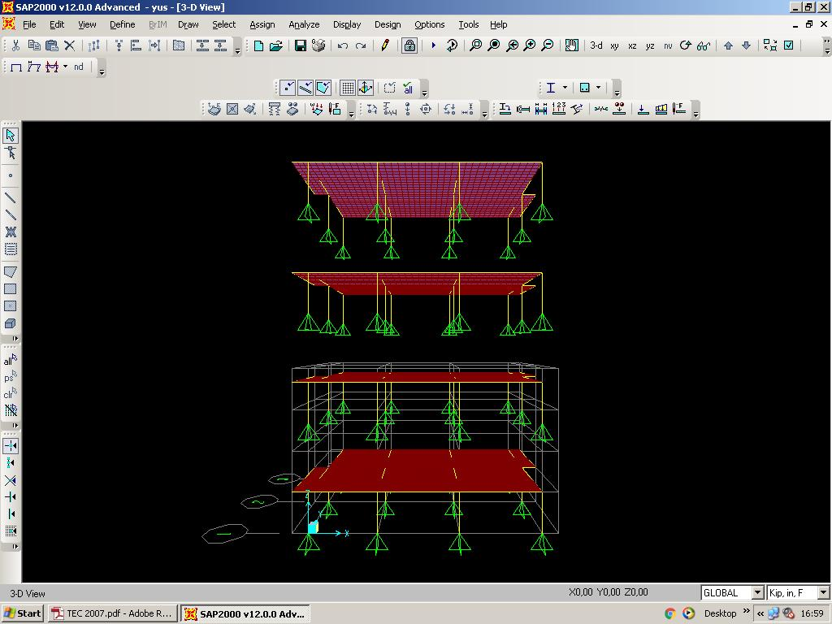

**Figure 12.** The joint loads of earthquake in the x-direction (left). And the seperation of storeys that to find loads on each column and total storey weights (as you can see at Table 2) is shown (right).

**DAY 15 - August 10, Wednesday- Calculation of the** [**relative floor displacement**](http://tureng.com/tr/turkce-ingilizce/relative%20floor%20displacement)

The effective relative storey drifts was calculated following minor revision in storey weights. Therefore, this was done by taking the data from the animation which is run on SAP2000. After that, the design of column was checked by examining the accuracy of moment and axial forces values. If the concrete grade will be selected C35 concrete, it is possible to obtain a value under the critical one. However my design would remain same as before. In the end, I started to draw the [axial load-moment interaction diagram](http://tureng.com/tr/turkce-ingilizce/axial%20load-moment%20interaction%20diagram).

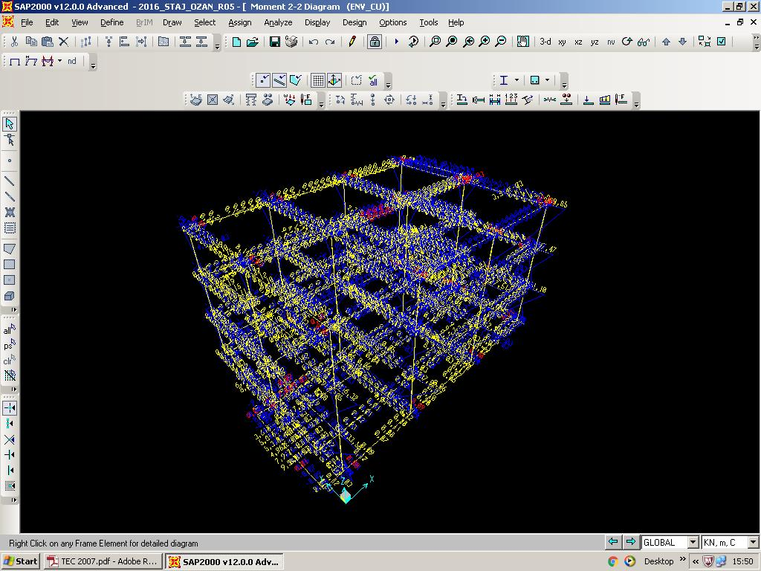

**Figure 12.** moment 2-2 diagram ENV_CU

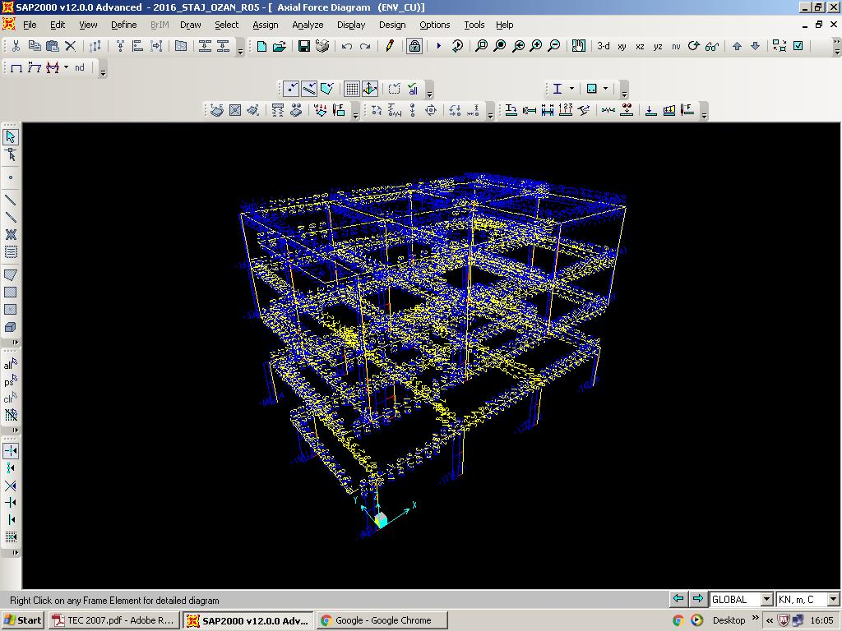

**Figure 13.** axial force diagram ENV_CU

**DAY 16 – August 11, Thursday-** [**Drawing axial load-moment interaction diagram**](http://tureng.com/tr/turkce-ingilizce/axial%20load-moment%20interaction%20diagram)

The [axial load-moment interaction diagram](http://tureng.com/tr/turkce-ingilizce/axial%20load-moment%20interaction%20diagram) is drawn for the behavior of column 400x 400 mm in size. For this, I benefited from the unit “ Combined bending – Bearing capacity of elements under axial compression and bending” of the book of “ Betonarme” written by Uğur ERSOY and Güney ÖZCEBE who are former professors of our department. Making all calculations and drawing diagram are completed for the column type (8 ϕ16) what my supervisor wants to me. At the latter end, I could check all results by the help of the macro “Analysis of the rectangle column” which was created by same professors on [Excel](http://tureng.com/tr/turkce-ingilizce/excel%20macros).

**DAY 17 - August 12, Friday - Soil survey**

Today, project manager Mr. Öztürk requested a soil survey for an actual work from me and my internship friend Ufuk. At paper mills to constructed in Eskişehir, we printed out [architectural drawings](http://tureng.com/tr/turkce-ingilizce/architectural%20drawings), foundation reinforcement plan and sections, foundation formwork plan and sections, foundation drawings of grounds that paper machines will be fitted. We inspected on all of these. After that, we examined [soil investigation report](http://tureng.com/tr/turkce-ingilizce/soil%20investigation%20report) dedicated by employer. And according to all of them, the foundation modelling is started on SAP2000.

**DAY 18 - August 13, Saturday- Soil survey & Foundation design**

I loaded on foundation modelling prepared on SAP2000. Afterwards I defined springs on the horizontal ( both X and Y directions) and vertical (in bottom direction) directions. I obtained deformed shape of modelling thereafter “Run Now” command is used by choosing necessary load combination that called “ENV_CS”. The σmax calculation is done with the maximum deformation found from this shape ( σmax= (kc*14000)*λ ) . At the end, maximum moments M11 and M22 is computed by using with other load combination named as “ENV_CU” and shear force Vmax is computed by using with another load combination named as “CU002”. Finally, I made a report on Word by the help of all these obtained results and filled values at reinforcement file on Excel given to us.

**DISCUSSION PART**

**WEEK 3**

In third week of my summer practice, I focused working on modelling much more. In this week, I [drawed axial load-moment interaction diagram](http://tureng.com/tr/turkce-ingilizce/axial%20load-moment%20interaction%20diagram), thus I used what learned about reinforced concrete at last semester. In other words, I put what I know into practice. When I drawed this, I comprehended the in relation with axial load and moment. And by making the soil survey my intern friend together at one day, I gripped how teamwork happened and time management. The reason is that both business development & quotation department manager and project manager asked for report until Monday to publish it. Also by making this work, even if just a pinch I understood how foundation is designed. In summary, at the last two days of week, I started to make soil survey and also foundation design. In this way, I helped my supervisor. So, this made feel effective myself in this office although I am an intern.

**WEEK 4**

**DAY 19 – August 15, Monday- Preparing the report of** [**reinforced concrete**](http://tureng.com/tr/turkce-ingilizce/reinforced%20concrete)[**static calculation**](http://tureng.com/tr/turkce-ingilizce/static%20calculation)

We started to prepare the report about the project that modelling and analysis had previously finished on SAP2000. For this, our supervisor Mr. Öztürk gave us a sample old report and he asked for us to prepare a report like that. We prepared this required report by compiling data on [soil investigation report](http://tureng.com/tr/turkce-ingilizce/soil%20investigation%20report), Excel and SAP2000. Then we immediately submitted a report of the engineer’s room that is not included in soil survey after we analysed on SAP2000, examined on Excel and prepared it on Word respectively.

**DAY 20 – August 16, Tuesday- Analysing beam and slab**

After finishing the analysis of the column, analysing of the beam and slab are started. For this process, "TS500-Requirements for Design and Construction of Reinforced Concrete Structures" have reconsidered. And started to obtain values from SAP2000 analysis results (Table 3).

**Table 3.** The maximum shear and moment values of beams obtained from SAP2000.

|  |  |  |  |  |  |  |  |  |  |  |
| --- | --- | --- | --- | --- | --- | --- | --- | --- | --- | --- |
| **TABLE: Element Forces - Frames** | | | | | | | | | | |
| **Frame** | **OutputCase** | **CaseType** | **P** | **V2** | **V3** | **T** | **M2** | **M3** | **FrameElem** |
| B20 | CU018 | Combination | 8,014 | -146,329 | 0,227 | 5,1635 | 0,0931 | -225,8063 | B20-1 |
| B20 | CU017 | Combination | 7,913 | -145,141 | -0,276 | -4,1066 | -0,1241 | -224,4966 | B20-1 |
| B8 | CU013 | Combination | 6,424 | -143,551 | 0,293 | 4,3627 | 0,1199 | -223,5084 | B8-1 |
| B8 | CU014 | Combination | 6,294 | -143,203 | -0,311 | -5,7832 | -0,1373 | -223,002 | B8-1 |
| B22 | CU017 | Combination | 8,612 | -142,714 | -0,836 | -5,0738 | -0,3742 | -198,4559 | B22-1 |
| B20 | CU018 | Combination | 8,014 | -141,609 | 0,227 | 5,1635 | -0,0204 | -153,8218 | B20-1 |
| B20 | CU002 | Combination | 4,729 | -140,429 | -0,071 | 0,7789 | -0,0415 | -170,6047 | B20-1 |
| B20 | CU017 | Combination | 7,913 | -140,421 | -0,276 | -4,1066 | 0,0138 | -153,1062 | B20-1 |
| B89 | CU002 | Combination | -12,57 | -140,231 | 0,221 | 0,3611 | 0,121 | -162,9457 | B89-1 |
| B18 | CU017 | Combination | 7,503 | -140,16 | -0,091 | -2,7941 | -0,0467 | -219,0058 | B18-1 |
| B22 | CU018 | Combination | 7,605 | -138,969 | -0,977 | 1,1706 | -0,4343 | -194,4769 | B22-1 |

**DAY 21 – August 17, Wednesday - Calculation the reinforcement of the beam, column and slab**

The necessary formulas for analysis of beam and slab are achieved from Turkish Standard named as “ TS500- Requirements for Design and Construction of Reinforced Concrete Structures”. Then I completed the design of beam and column according to these formulas and constraints. After designing the beam and slab, I obtained balanced reinforcement details. Because of the insufficient of two lines of columns which are 400x 400 mm in size in the middle of structure, these are changed to dimensions of 500x 500 mm. Finally, the first natural vibration period of the building is calculated once again (Table 4).

**Table 4.** The first several vibration periods of the building obtained from SAP2000.

|  |  |  |  |  |  |
| --- | --- | --- | --- | --- | --- |
| **TABLE: Modal Participating Mass Ratios** | | | | | |
| **OutputCase** | **StepType** | **StepNum** | **Period** | **UX** | **UY** |
| Text | Text | Unitless | Sec | Unitless | Unitless |
| MODAL | Mode | 1 | 0,617574 | 0,00 | 0,84 |
| MODAL | Mode | 2 | 0,605333 | 0,86 | 0,00 |
| MODAL | Mode | 3 | 0,551164 | 0,00 | 0,01 |
| MODAL | Mode | 4 | 0,20065 | 0,00 | 0,10 |
| MODAL | Mode | 5 | 0,197656 | 0,10 | 0,00 |
| MODAL | Mode | 6 | 0,180886 | 0,00 | 0,00 |
| MODAL | Mode | 7 | 0,117957 | 0,00 | 0,03 |
| MODAL | Mode | 8 | 0,116926 | 0,03 | 0,00 |
| MODAL | Mode | 9 | 0,107972 | 0,00 | 0,00 |
| MODAL | Mode | 10 | 0,091802 | 0,00 | 0,00 |
| MODAL | Mode | 11 | 0,090228 | 0,00 | 0,00 |
| MODAL | Mode | 12 | 0,087971 | 0,00 | 0,01 |

**DAY 22 – August 18, Thursday - Calculation building period & Checking reinforcement**

The new first natural vibration period of the building was T= 0.62 seconds. (Table 4) ( The previous one was T= 0.65 seconds). Because of the variation was 5% between them and this did not affect the design of building excessively, together I and my supervisor took a decision that do not make any changes. Two lines of columns which are 400x 400 mm in size in the middle of structure were revised to dimensions of 500x 500 mm for each floor on SAP2000 because I noticed that these fail under uniaxial compressive strength. Now I controlled whether columns in these sizes were sufficient for building strength with the same calculation method from the book of “ Betonarme” . I saw these values under the [axial load-moment interaction diagram](http://tureng.com/tr/turkce-ingilizce/axial%20load-moment%20interaction%20diagram). Also I checked shear force of a beam in this case. I had an interest in the +0.00 elevation of the project known as " Soma Power Plant – J14 Air Compressor Building and Distribution Work" after my supervisor had given it to me. These projects are "Ground slam formwork, plan & sections" and "Equipment foundation drawing" . I marked wrong and missing parts of these projects. In the end, I calculated total weights.

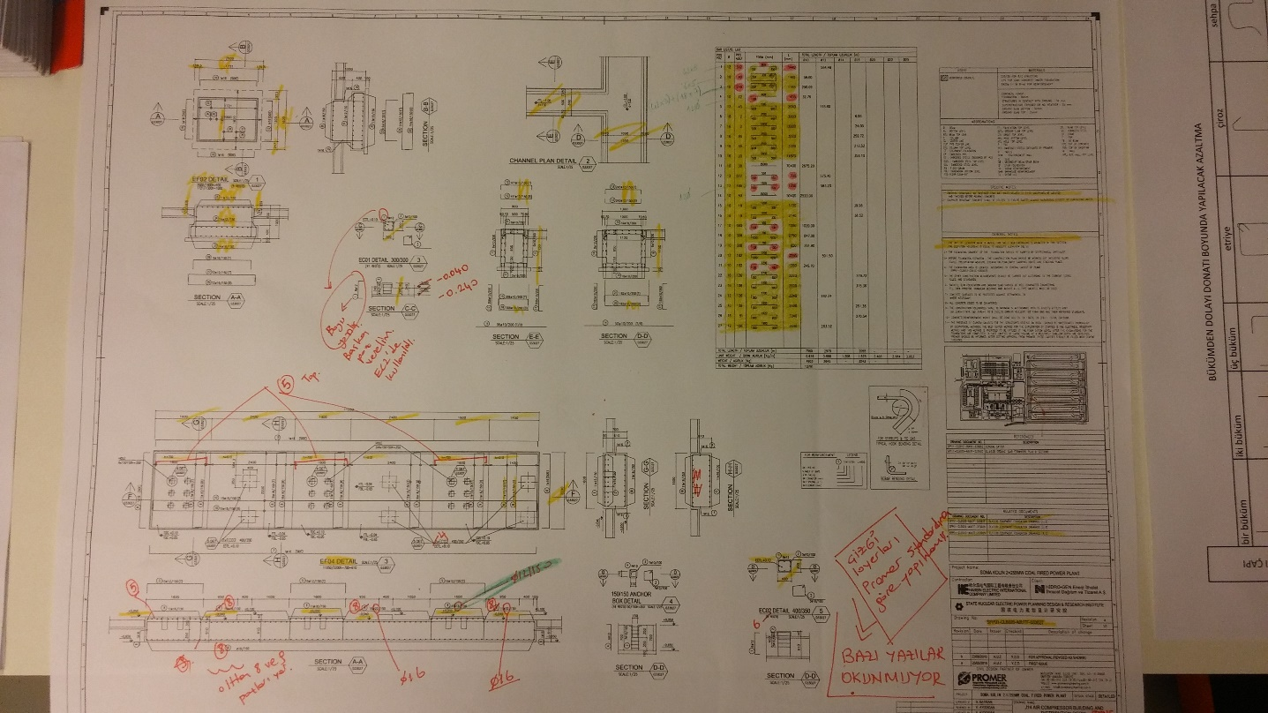

**Photograph 3.** Anequipment foundation drawing of the " Soma Power Plant – J14 Air Compressor Building and Distribution Work”

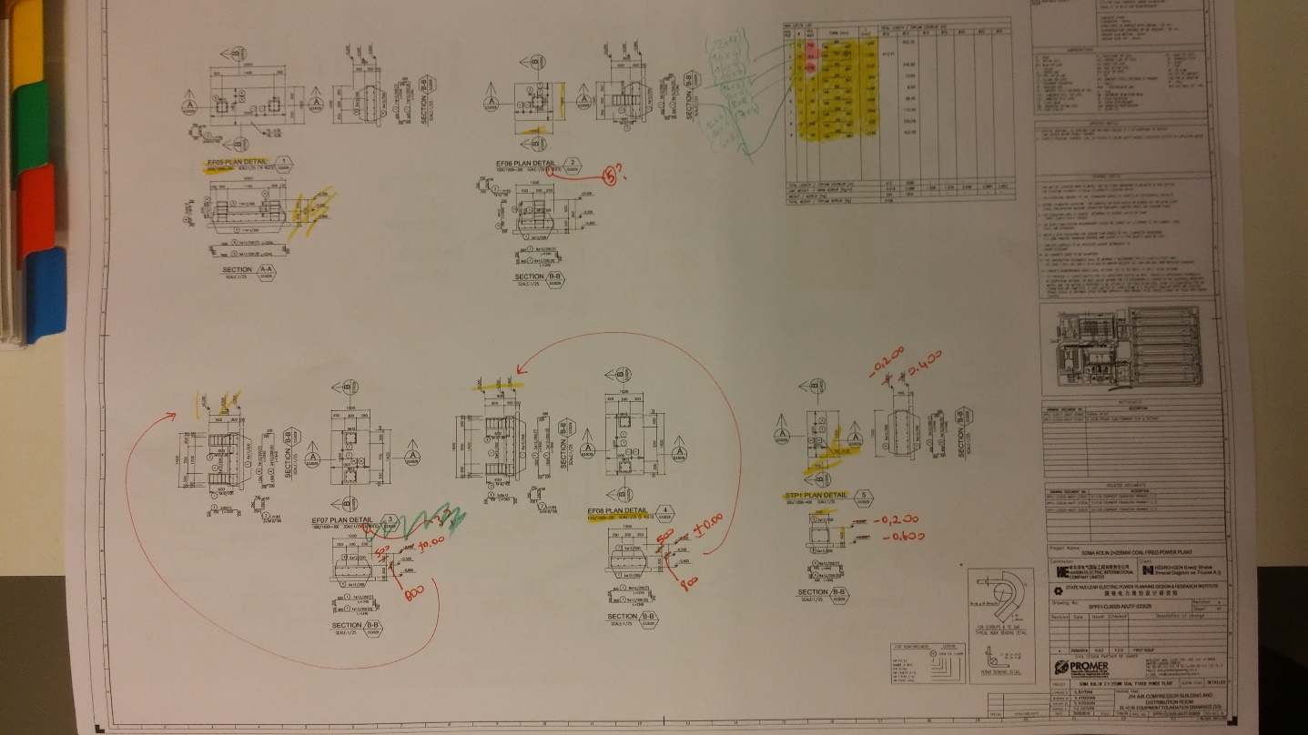

**Photograph 4.** Another equipment foundation drawing of the " Soma Power Plant – J14 Air Compressor Building and Distribution Work”

**DAY 23 – August 19, Friday – Foundation design**

I started the design of the [continuous footing](http://tureng.com/tr/turkce-ingilizce/continuous%20footing) after I had finished design for floors. First of all, I defined “Pin” that prohibit the movement of the building in the direction of the “ Translation 1” and “ Translation 2” at points of under each column. I absolutely removed previous spring with the command “ Joint Restraints” before that. The [continuous footing](http://tureng.com/tr/turkce-ingilizce/continuous%20footing) had 1 meter high. Plus , “ mesh area” was defined and divided to it squares 0.5x0.5 m in size same as before. And I defined “Area springs” under the all area. (Spring stiffness, k= 20000; Direction: Bottom) . According to Turkish Earthquake Code (6.3.2.1) , soil stress, q is accepted q for static state, 1. 5 q for dynamic state for a safe foundation design. To analyse the foundation, I defined two combinations are called as " ENV_CS_STATIC" and " ENV_CS_DYNAMIC" . " ENV_CS_STATIC" consisted of combinations CS001 to CS010 that do not contain seismic load and " ENV_CS_DYNAMIC" consisted of combinations CS011 to CS018 that contain seismic loads. I loaded loads DL1= 12 kN/ m2 and LL= 2 kN/ m2 by assuming the made-up ground is 60 cm high on the foundation. Under these circumstances, when a analysis was made I [distinguish](http://tureng.com/tr/turkce-ingilizce/distinguish)ed foundation was over critical value for a lot of points. Therefore, we took a decision about enlarge the cross section of foundation. When critical parts on edges were enlarged 2 meters and columns which are placed in the middle of structure were enlarged 1 meter, the foundation will rank among in the safe range. Later, I checked Uzmax for all combinations of CS. The meaning of the positive value for any CS combination is that there is pulling force at that point. And we need remove the spring that present under the foundation in the face of this situation. I checked overturning after this process. I calculated the moment by producting total storey weight and design seismic loads acting at storey levels with the perpendicular distance between and under the foundation. I confirmed that the building is safe. I did sums of reinforced concrete foundations with M11max and M22max that are obtained on SAP2000 for the " ENV_CU" combination. In the end, I controlled shear force. I did this by the help of calculation in the standard is “ TS500- Requirements for Design and Construction of Reinforced Concrete Structures” .

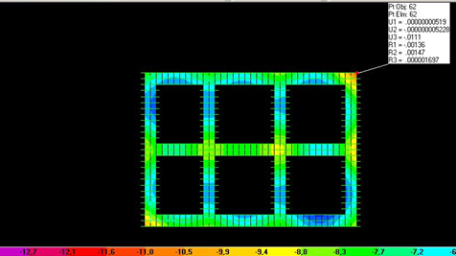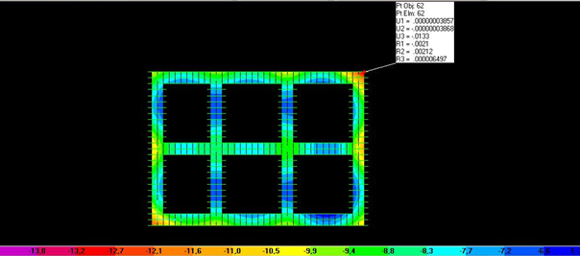

**Figure 14.** The initial deformed shapes of the combinations " ENV_CS_STATIC" (left) and " ENV_CS_DYNAMIC" (right).

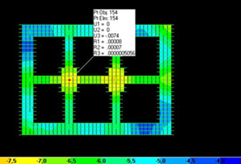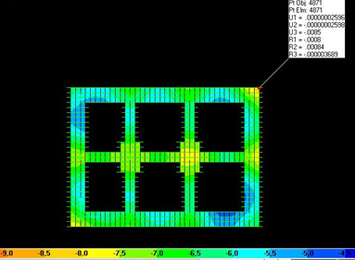

**Figure 15.** The deformed shapes of the combinations " ENV_CS_STATIC" (left) and " ENV_CS_DYNAMIC" (right) after critical parts were enlarged.

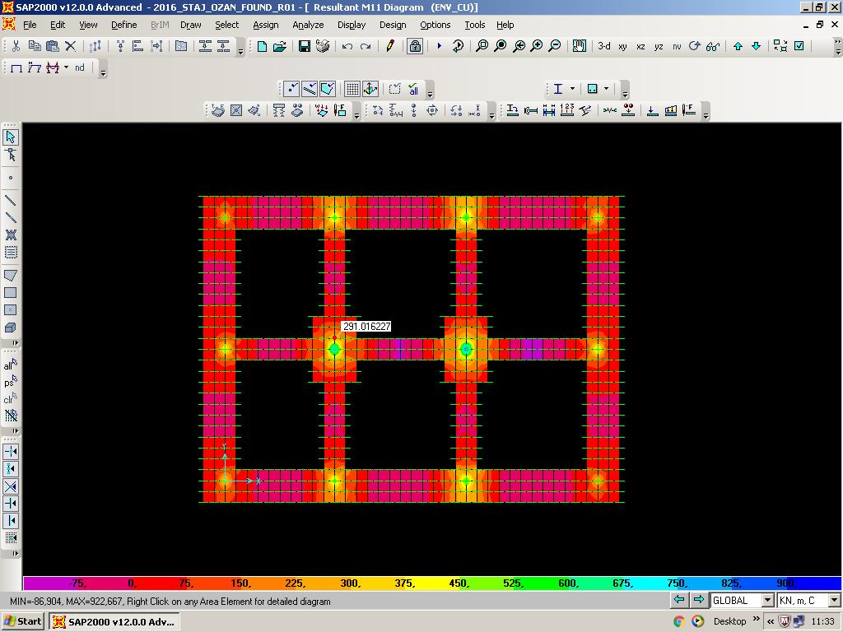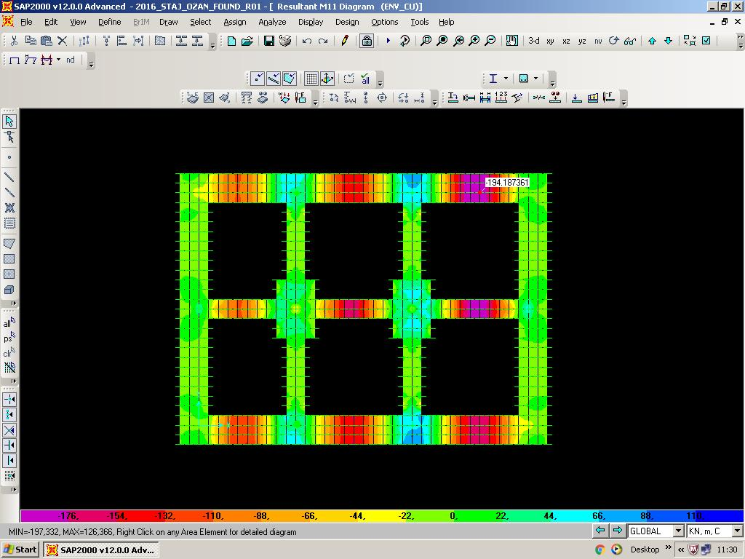

**Figure 16.** The maximum moment values- positive one (left) and negative one (right)- of M11 with the " ENV_CU" combination.

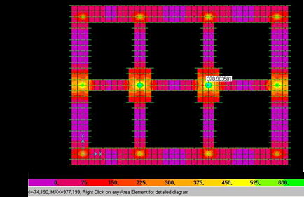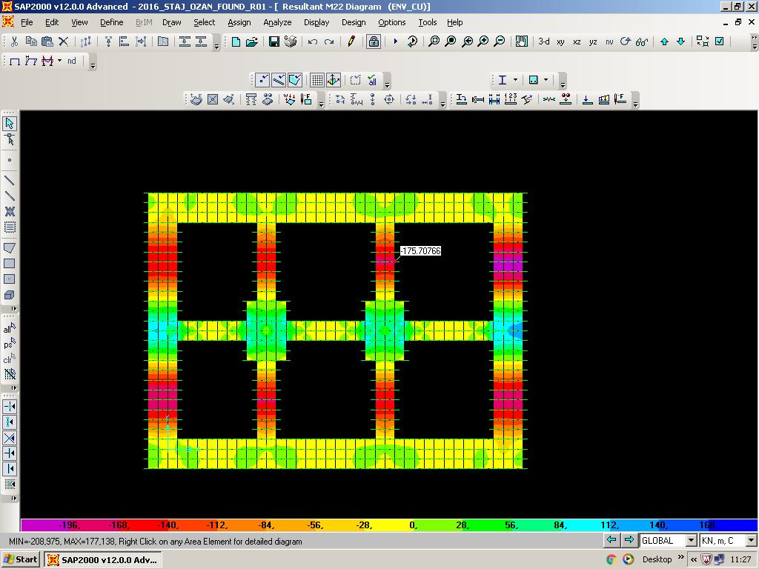

**Figure 17.** The maximum moment values- positive one (left) and negative one (right)- of M22 with the " ENV_CU" combination.

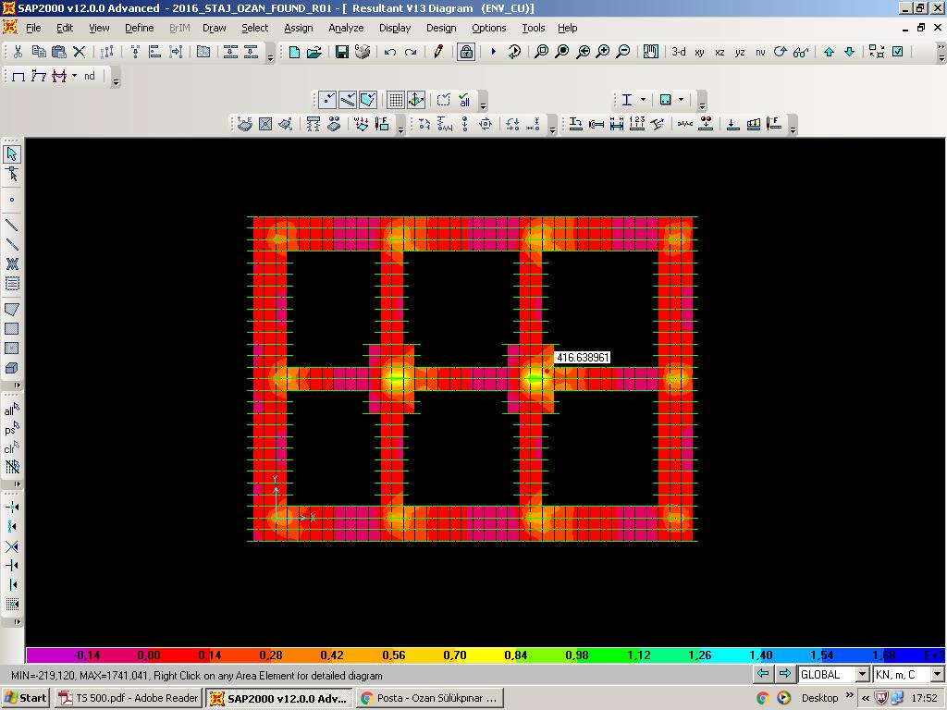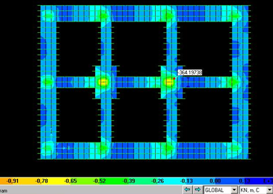

**Figure 18.** The maximum shear values- positive one (left) and negative one (right)- of V13 with the " ENV_CU" combination.

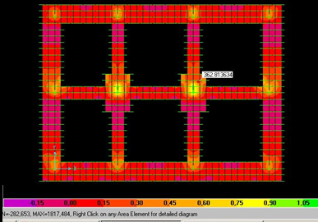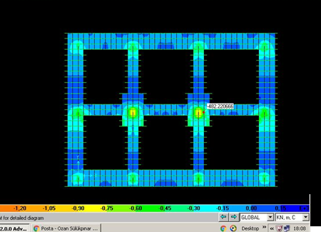

**Figure 19.** The maximum shear values- positive one (left) and negative one (right)- of V23 with the " ENV_CU" combination.

**DAY 24 – August 20, Saturday – Project reading**

Project reading is that analysing the reinforcement of floor, beams and columns and so on. We learnt what stirrup, one bend bar, two bend bar, three bend bar, distance pieces and standee mean and reading number, length and diameter of bars. Stirrup is the rectangular structure that corded  beams at regular intervals vertically. Stirrup‘s size and the diameter of used bars are showed on the project. One bend bar, two bend bar and three bend bar are standard bar bending shapes have one, two and three twists on their structure respectively. Distance pieces are generally S-shaped bars that connect vertical mutual bars used in columns or shear walls at reinforced concrete structures. Standee is an iron bar that its shape resemble a table. It prevents the collapse of top reinforcement. Also, we learnt symbols and abbreviation of them.

**DISCUSSION PART**

**WEEK 4**

In the fourth week of my summer practice, I studied very kind of works. In the first working day of the week, I continued the job of foundation design. I prepared a [reinforced concrete](http://tureng.com/tr/turkce-ingilizce/reinforced%20concrete) [static calculation](http://tureng.com/tr/turkce-ingilizce/static%20calculation) report about it. And a lot of subtitles like general layout, [soil properties](http://tureng.com/tr/turkce-ingilizce/soil%20properties), usability limits, load combinations, steel design, R/C design etc. are taken into consideration to prepare it.

After related formulas had obtained, I maked calculations for analysing beam, column and slab. Because columns have insufficient compressive strength as is understood from calculations, I revised sizes of columns in the middle of structure. Then I may construe why company always revise when they design a structure. And also this situation show me that there is no exact and constant solution on a [project in design stage](http://tureng.com/tr/turkce-ingilizce/project%20in%20design%20stage). After this work, I calculated building period [in the light of the last revision](http://tureng.com/tr/turkce-ingilizce/in%20the%20light%20of%20the%20new%20information). [The beautiful of it is](http://tureng.com/tr/turkce-ingilizce/the%20beautiful%20of%20it%20is) that I used the book of “ Betonarme”. It was very helpful and edifier book and I will definitely get one for my library.

The another work I interested in this week is that finding wrongs on projects about “ Soma Power Plant”. It was enjoyable work because it provided a basis that I and my internship friend worked together [interactively](http://tureng.com/tr/turkce-ingilizce/interactively).

Foundation design is the last stage of my design to finish it. But also it was the most diffucult stage on SAP2000. Even so by the helps of my supervisor, I understood the foundation design well enough.

In the day of project reading, I met reinforcing bars that I had already known from my site internship. But this time it is different. I saw them only on the Project, not when they are applied. Even so I remembered and penetrated to read a project. Certainly I will use these things I learned in my career many times.

**WEEK 5**

**DAY 25 – August 22, Monday- Checking reinforcement & controlling formwork**

Today my job were the checking reinforcement and controlling formwork of the project that my supervisor gave me. The name of this project was "ZETES III 2x660 MW Powerplant " and it is also constructed. The reviewed work I did was the "M35 Conveyor-Gallery, Channel foundation reinforcement plan and sections" . The design institute of the project was "Harbin Electric International Company Limited (HEI)" . I made check the size of [bar cross-section](http://tureng.com/tr/turkce-ingilizce/bar%20cross-section), length of bars, number of bars, placement of reinforcement, elevation control and details of guideline respectively. The purpose of checking is the confirming [drawings](http://tureng.com/tr/turkce-ingilizce/accuracy) of the draftsman after the project manager Mr. Öztürk had sent how reinforcement detailing should be on the project to [draftsman](http://tureng.com/tr/turkce-ingilizce/draftsman). Wrong parts I found are marked. Eventually, together we checked plans and I delivered them to my supervisor.

**DAY 26 – August 23, Tuesday- Checking reinforcement**

I resumed the control of reinforcement. I found the reduction in the length of one bend bar, two bend bar, three bend bar, stirrup, distance piece and standee by taking advantage of the table called as “ Reduction in the bar lengths due to bending ” by considering reinforcement diameters. After that I checked the accuracy of the total length of reinforcement within these reductions. In the end, I marked correct parts with yellow pencil and wrong parts with red one.

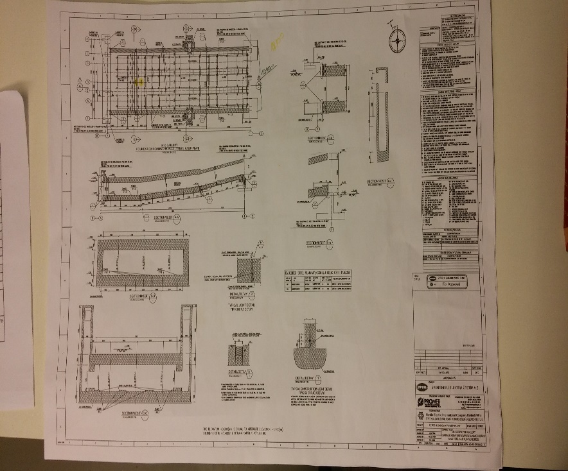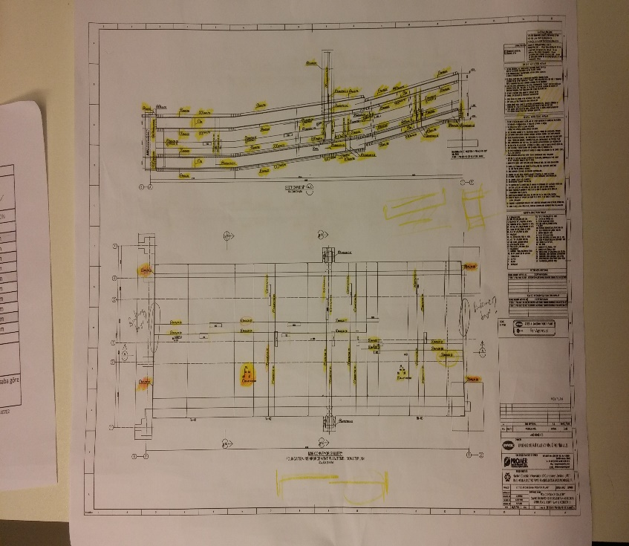

**Photograph 5.**

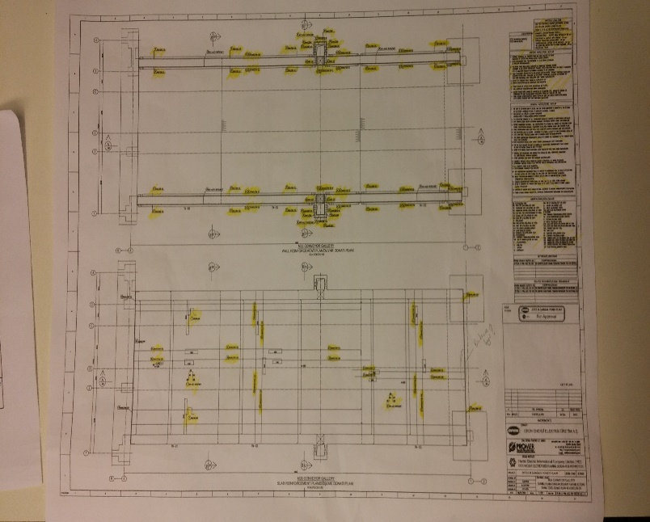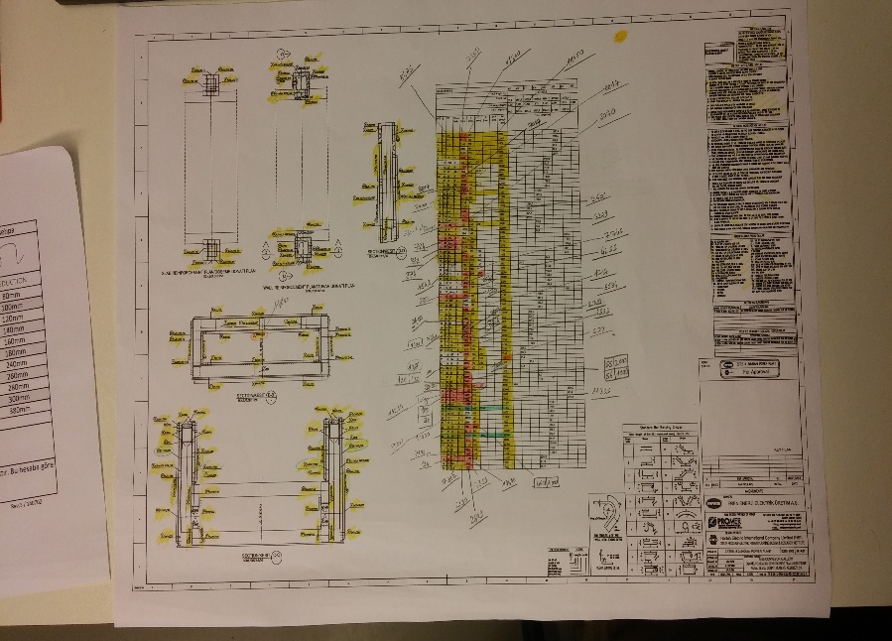

**Photograph 6.**

**DAY 27 – August 24, Wednesday – Performing quantity takeoff of iron**

Performing quantity takeoff of bar is a calculation that find out the total used bars according to the project. Performing quantity takeoff of bar is approached by classifying with respect to their diameters: ϕ12, ϕ14, ϕ16, ϕ20, ϕ22, ϕ25. Total used bar kilogram is calculated by using number, length and diameter of used bars. And again, I marked correct parts with yellow pencil and wrong parts with red one.

**DAY 28 – August 25, Thursday – Revision of checking reinforcement**

According to my revision, after draftsman fixed the drawings, he sent it back to us again. This time I looked over to verify the project is completely correct at the very end. According to previous situation of the project, such properties like length and number of the various bars were changed. Considering all these, I checked critical points but I couldn’t find any significant error except a few minor ones. Even so, I reported this situation to my supervisor and handed over plans.

**DAY 29 – August 26, Friday – General Review**

After finishing all calculations and examinations about my design, my supervisor recommended me to review all my studies I did until today. Thus, both I could repeat what I did during all my internship period in detail and there will not [put a question mark in the my mind](http://tureng.com/tr/turkce-ingilizce/put%20a%20question%20mark%20in%20the%20minds). Primarily, I checked grid together with column, beam and slab at the modelling on SAP2000. Later, checked on defining and loading of loads such as dead, live, wind and seismic load, load patterns and load combinations. And I did this with regard to standards and thereinafter, I looked over calculations of the seismic load and the [relative floor displacement](http://tureng.com/tr/turkce-ingilizce/relative%20floor%20displacement) on Excel and SAP2000. After some calculations, I confirmed that pages of [drawing axial load-moment interaction diagram](http://tureng.com/tr/turkce-ingilizce/axial%20load-moment%20interaction%20diagram) and calculation the reinforcement of the beam and slab are correct. Eventually, I examined calculations of building period and foundation design on SAP2000 one by one. After crosschecking all of them, I couldn’t find any error regarding my design. And I notified this to Mr. Ozturk.

**DAY 30 – August 27, Saturday – Finishing up the internship**

In the last day of my internship, to be finished with work I went to human resources department. They checked my working days and hours from AURO system. When they confirmed my internship is finished, they deregistered me. After the deregistration process is finished, I collect my papers that I prepared during all my internship period. I said goodbye engineers, draftsmans and all other employees. Also, I gave back the manual of the [“Standards](http://tureng.com/tr/turkce-ingilizce/standards) and auxiliary charts” to my supersivor. And I thanked him for all his help during my internship.

**DISCUSSION PART**

**WEEK 5**

In the last week of my summer practice, although my time is on the way, I worked more. Generally, I studied on reinforcement checking.

Reinforcement can be collected under three titles: foundation, slab and wall reinfrocements. For foundation reinforcement, there are straight bars, extras and standees; for slab reinfrocement, straight bars, extras and standees; for wall reinforcement, distance pieces, stirups, one bend bars, two bend bars and three bend bars individually. Straight bars are long bars found among two walls and between edges of foundation or slab. Extras are shorter bars than straight bars and  extend along foundation or slab. In checking of reinforcement, we controlled the using of straight bar, extras, standees, , distance pieces, stirups, one bend bars, two bend bars and three bend bars like project. At this stage, bar lengths, diameters, number and distance between the bars and using the right points are essential.

Undoubtedly that these should be stated on the project correctly. The revision is crucial process in this sense. So, draftsman [has big responsibility](http://tureng.com/tr/turkce-ingilizce/assume%20the%20responsibility) alone and does not have a chance of making a mistake in this work, But sometimes I saw intervention of engineer when anything goes wrong and solve this problem practically.

At the last two days of week**,** I got ready tofinish with work. I controlled again all works I did during my internship. Thanks to review, I penetrated all steps of the design of a reinforced concrete building.

**INTERVIEW WITH SUPERVISOR**

I made an interview with Mr.Yusuf Ziya Öztürk who is the one of the R/C structures design engineers and also my supervisor. And I asked some questions about his experience in the business life of civil engineering:

* Could you introduce yourself briefly?
  + First of all, I would like to state that it was a great pleasure to work with Mr. Ozan Sülükpınar within 1 month for your internship period. I am 33 years old and living in Ankara. Regarding my civil engineering career, it has been started in 2006 year when throwing my cap in Gazi University Campus with 2nd grade of honor.
* Why did you choose to become a civil engineer? How long have you worked and which companies have you been in?
  + At beginning of my high scool education, I have realized my interest in physics and found myself more successful in this branch compared with others, I think it is the main reason to select/work in structural engineering. In my early years I had worked for a company in water resources sector as a design engineer. Afterward I had attended Msc education in Gazi University in Geotechnical department and entered in construction company and worked nearly 6 months as a field engineer. We have met with PROMER in 2010 year, and have been working here for 6 years.
* What would you like to change about your career [at this distance of time](http://tureng.com/tr/turkce-ingilizce/at%20this%20distance%20of%20time)?
  + I had planned an abroad education as M.Sc. after my graduation, but I could not have chance to achieve this, instead of this I have graduated M.Sc. in Gazi University in 2010.
* I’m a senior undergraduate student. What are the main advices you can give to someone who will graduate newly?
  + In order to find most exciting work where you can develop yourself acc to your personality/ priority cause it is nearly half or may be more than half of life, you should work different departments or may be different companies. You should be aware that life learning is a must in our sector.
* Do you suggest to do a master’s degree or doctorate ( in own country/ abroad) , is it important to work in the private sector?
  + I strongly suggest to make Msc in order to improve/find the solution techniques in face of difficulties in real work life. Importance of  this education is depands on where you work and what you do.
* What is the PROMER Consultancy Engineering like and what kind of projects is taken care of?
  + PROMER Consultancy Engineering is a firm that is giving engineering service to its national and international customers. PROMER has the ability to utilize the last versions of the technological design and detailing instruments; and has the capability to take the advantage of the national and international building codes. Main working heads are:
    - Architectural Designs, Industrial Buildings Engineering Services, Electrical, Mechanical and Installation Design Services, Infrastructure Designs, Treatment Plant Designs, Feasibility Studies, Consultancy Services, Site Supervisioning.
* If you evaluate the PROMERConsultancy Engineering about working conditions objectively, what will you say?
  + In words of my friend, PROMER can be defined as “champion’s league of design engineers”. In our company education level, engineering quality is very high as appreciated, compared with other national and international companies. It is big plus, but sometimes, work loading is also high; it may be the minus point for us.
* What is your position in the company currently? And can you tell me what projects are you working on?
  + I work as a lead design engineer in some projects, such as cement plants in Katar, Mexico, Algeria (QNC5, TUL2, CHL1).
* Why did you choose to become a design engineer instead of in the fields of the civil engineering? Can you tell me about life (his/her problems, challenges ) of a design engineer?
  + In my early years I had worked for a company in water resources sector as a design engineer. Afterward I had attended Msc education in Gazi University in Geotechnical department and entered in Construction Company and worked nearly 6 months as a field engineer. We have met with PROMER in 2010 year, and have been working here for 6 years.  Every work has difficulties, I think that there is no easy way for working in private jobs ( except being a boss). Long working hours in a day, trying too hard to overcome on difficulties, lifelong learning ( it is a must) is apparent difficulties in our sector.
* How do you cope with troubles in business life?
  + I am known as a quit/calm man, in front of difficulties in work life. Instead of making instead decisions, I try to define the problem in deep and try to find more realistic & effective solutions.
* Have you ever experienced site before you started work in office? What did you gain experience about civil engineering at site and in office? Please compare these fields.
  + Actually I had worked as a resident engineer as described above, but priorities in life effect on choices and I have found it appropriate (working design engineer) for my personality & productivity.
* Where do you find more advantageous to work for a civil engineer? Own country or abroad? Site or office? Explain why.
  + Sometimes advantages are depends from person to person and definitions are changes. High salary with long working hours may be advantage for someone, but for another, reasonable working  hours & salary is advantage. Working in of front of computer 8 hours can be defined as boring for someone but for another it is comfortable. Therefore person firstly define what is the meaning of advantage in his/her life and this definition is also changes in different periods of life.

**CONCLUSION**

Summer practice is very important for civil engineers because many applications are learned at the office. During this summer practice, I have learned many new things about civil engineering, construction and the dialogue between the authorized people and the workers. Summer practice has also improved my skills of understanding the principles of project. The theoretical knowledge that is introduced in the faculty finally started to seem more realistic, when I observed them on actually working in office.

I have learned some important informations about my occupation. Engineers and draftsmans were very helpful and they always told me what I wonder and ask. Also, at office I learnt that:

-Responsibilities of a civil engineer

-[Human relations](http://tureng.com/search/human%20relations)

-Team work

-Business discipline

-Working schedule

- [Domain of applicability](http://tureng.com/search/domain%20of%20applicability) of academic knowledge

Moreover, I had the chance to compare my academic standing and capabilities by other students from universities such as Kırıkkale University and come up with a subjective conclusion that the quality of overall facilities that are served us by Middle East Technical University is way above than any other university in Turkey.

In overall, summer practice is one of the most yielding courses that I have ever attended throughout my three years at faculty. The reason of why I think in such an extent is that, without a summer practice I would never had a chance to have a first glance on my future. However I attended and now, I am glad having the privilege of organising my academic and social life, with the awareness of that I am now one step closer to the person that I will be tomorrow.

**APPENDICES**

**NOTATION**

Inc. – Incorporated

kN/ m² - kilonewton per square meter

kN/ m³ - kilonewton per cubic meter

DL- dead load

LL- live load

W- wind load

MW- megawatt

m- meter

cm - centimeter

mm- millimeter

m² - square meter

T- period

& - and

% - percent

‰ - [per mille](http://tureng.com/tr/turkce-ingilizce/per%20mille)

**REFERENCES**

PROMER Consultancy Engineering (n.d.-a) Retrieved September 20, 2016, from <http://www.promerengineering.com.tr/15/hakkimizda.aspx>

PROMER Consultancy Engineering (n.d.-b) Retrieved September 20, 2016, from <http://www.promerengineering.com.tr/organizasyon-semasi.aspx>

PROMER Consultancy Engineering (n.d.-c) Retrieved September 20, 2016, from http://www.promerengineering.com.tr/p1/engineering.aspx

TS 500/ February 2000 Betonarme Yapıların Tasarım ve Yapım Kuralları- Requirements for Design and Construction of Reinforced Concrete Structures, Turkish Standards Institution, Ankara, 2000

TS 498/ November 1997 Yapı Elemanlarının Boyutlandırılmasında Alınacak Yüklerin Hesap Değerleri-Design Loads for Buildings, Turkish Standards Institution, Ankara, 1997

TS648/ December 1980 Çelik Yapıların Hesap ve Yapım Kuralları- Building Code for Steel Structures, Turkish Standards Institution, Ankara, 1980

DBYBHY/ March 2007 Deprem Bölgelerinde Yapılacak Binalar Hakkında Yönetmelik- Specification for Buildings to be Built in Seismic Zones / Turkish Standards Institution, Ankara, 2007

Bowles, J.E. (1996). Foundation analysis and design. , (5th ed.). pp. 0-0 Singapore: McGraw-Hill.

Turkish Standards Institution

turkish standards

TS 500- February 2000 - Requirements for Design and Construction of Reinforced Concrete Structures

TS 498-Design Loads for Buildings

Turkish Earthquake Code 2007

TS648- Building Code for Steel Structures

Foundation Analysis and Design 5th Edition Joseph E. Bowles · Soil Mechanics